**Create the VPC and create two subnets as private and public subnets**

Go to View All Services -> Select VPC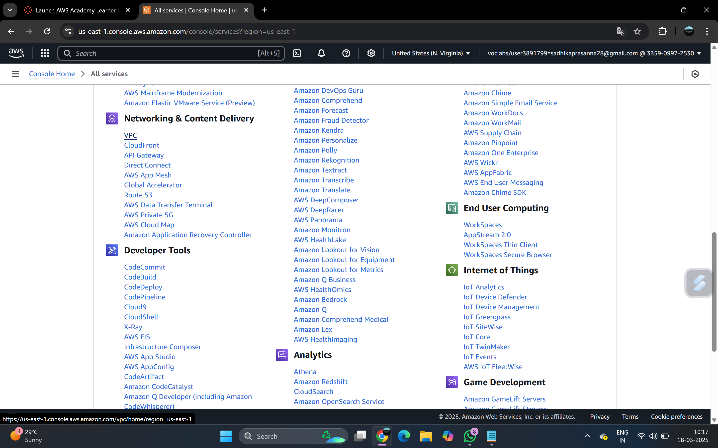

Click on create VPC

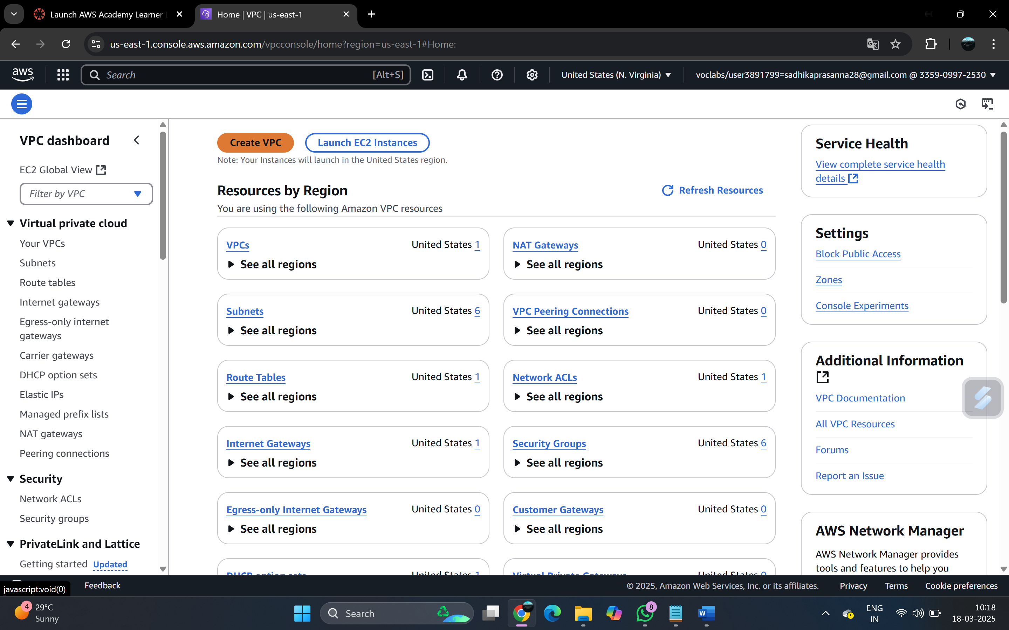

Select VPC only in resources to create and give name 58F-myVPC. Give IPv4 CIDR as 10.0.0.0/16 then click on create

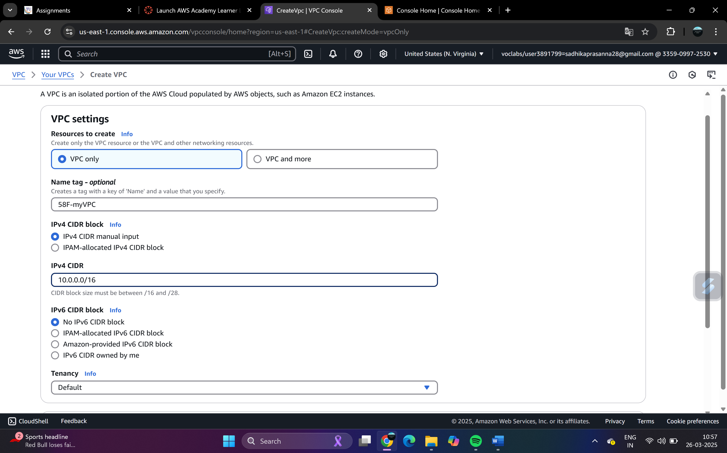

VPV created successfully

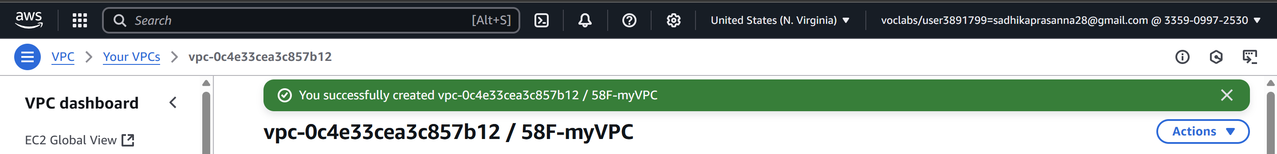

Go to subnets in the left panel of Virtual Private Cloud. Go to Create subnet

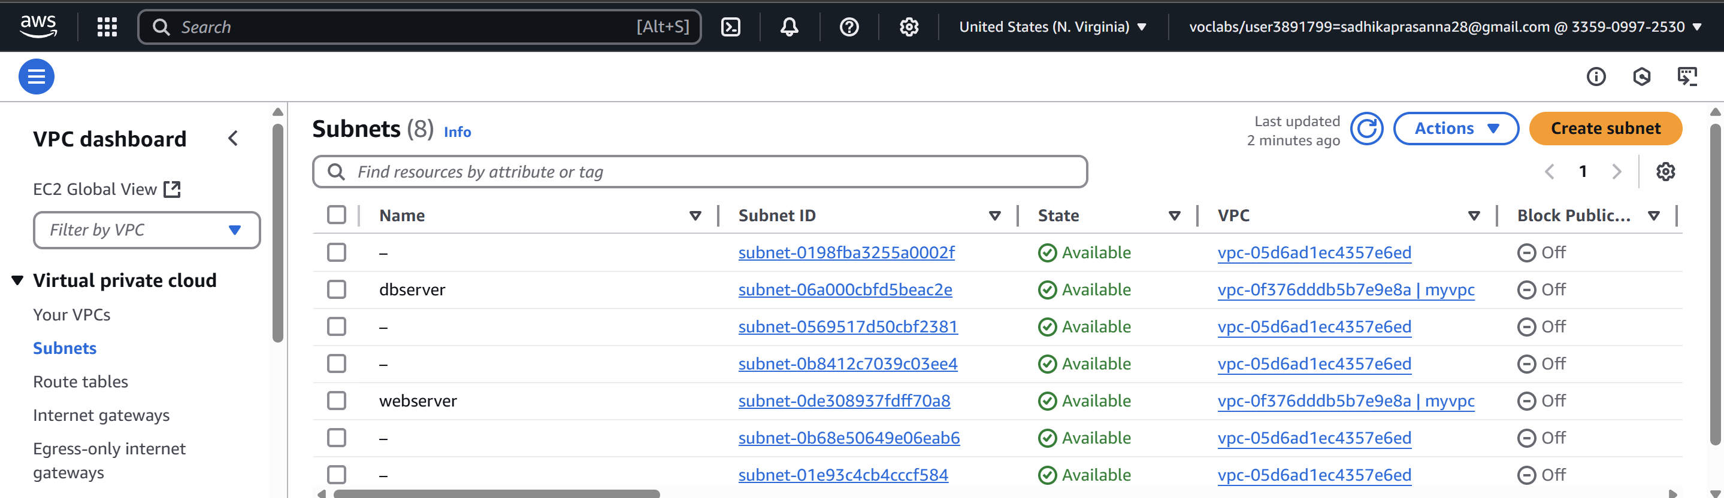

Select VPC ID (58F-myVPC)

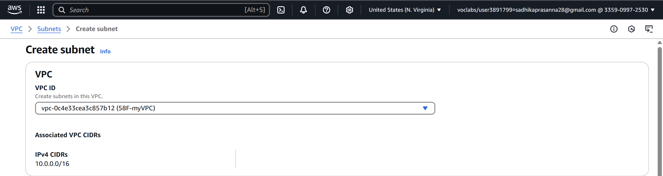

Give Subnet name as 58F-webserver and IPv4 subnet CIDR block as 10.0.1.0/24 -> Create

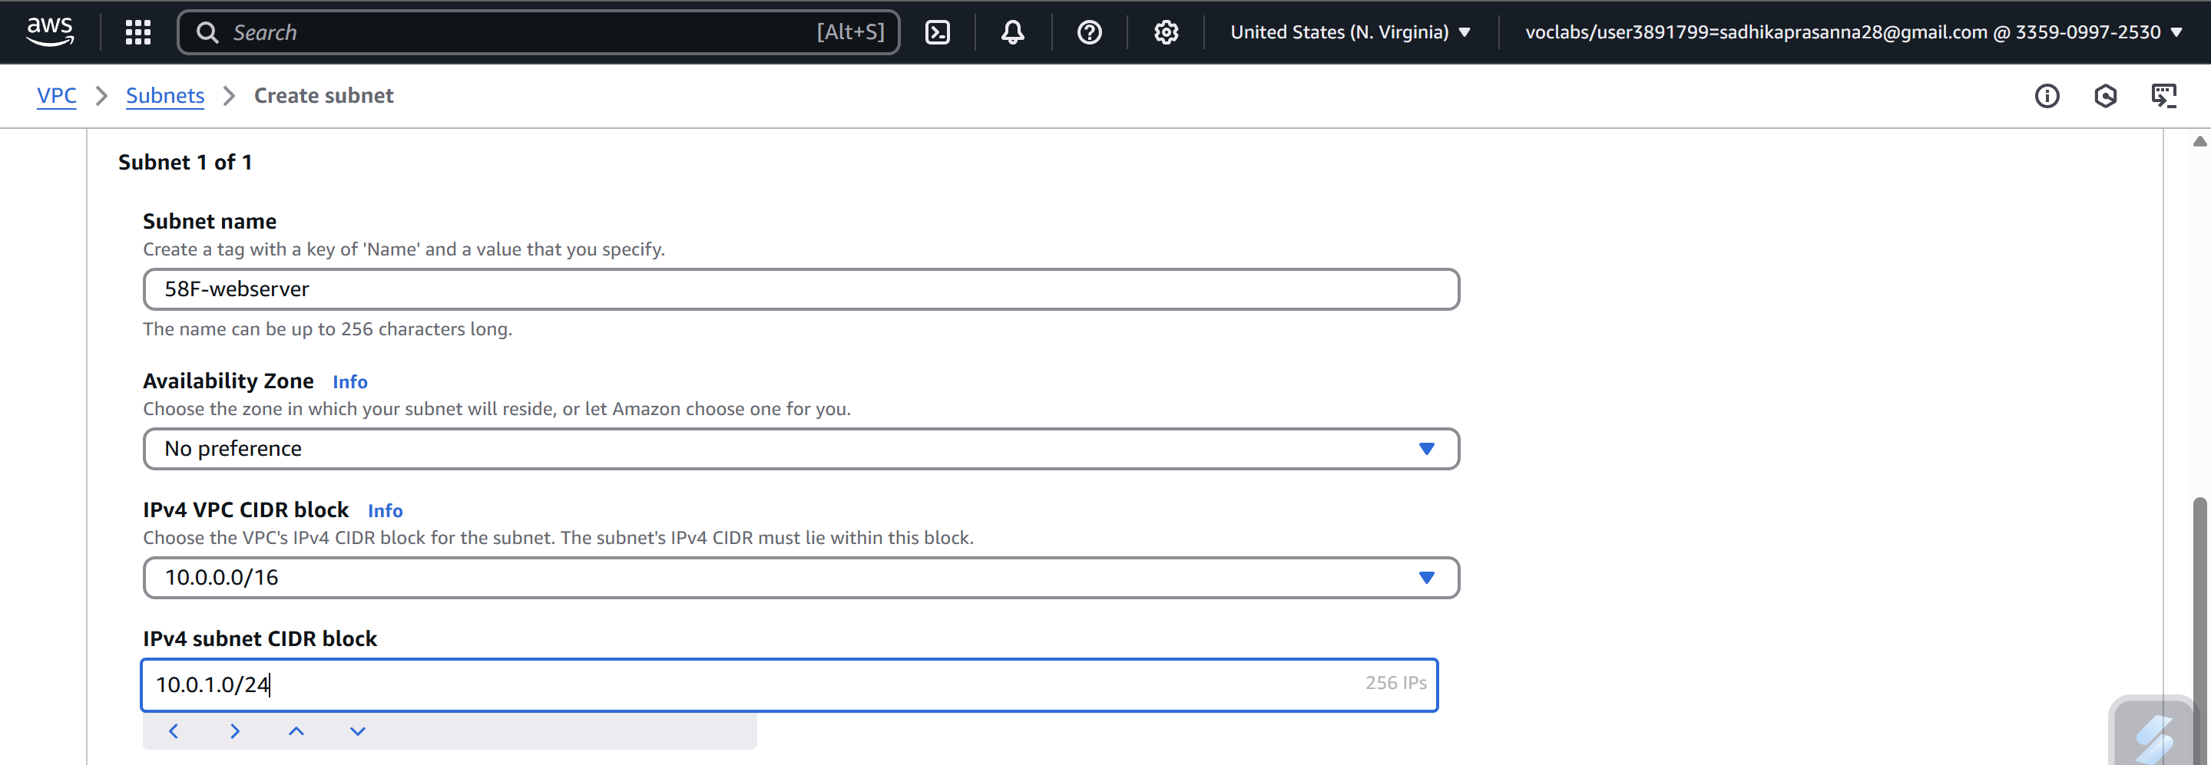

Create another subnet with name 58F-dbserver and IPv4 subnet CIDR block as 10.0.2.0/24 -> Create

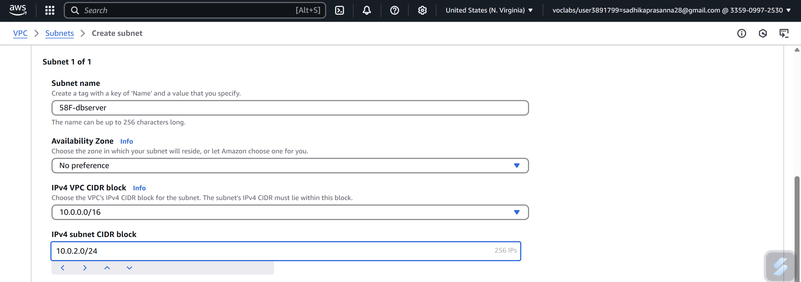

Go to subnets select webserver -> Actions select Edit subnet settings

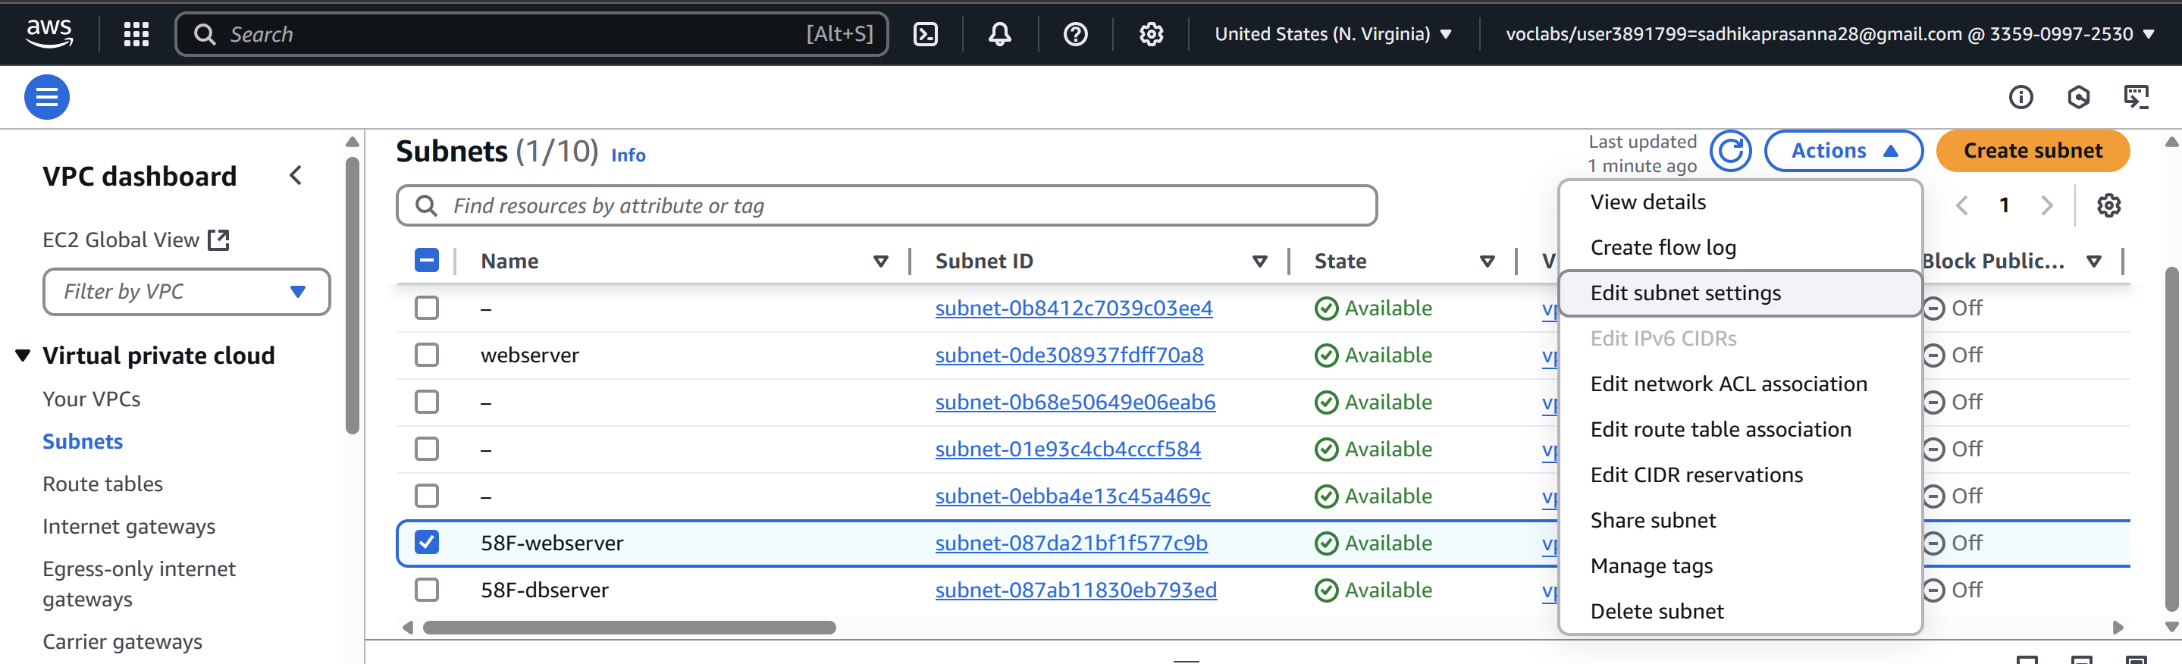

**Provide the internet connection to VPC**

Now enable auto-assign public IPv4 address -> Save

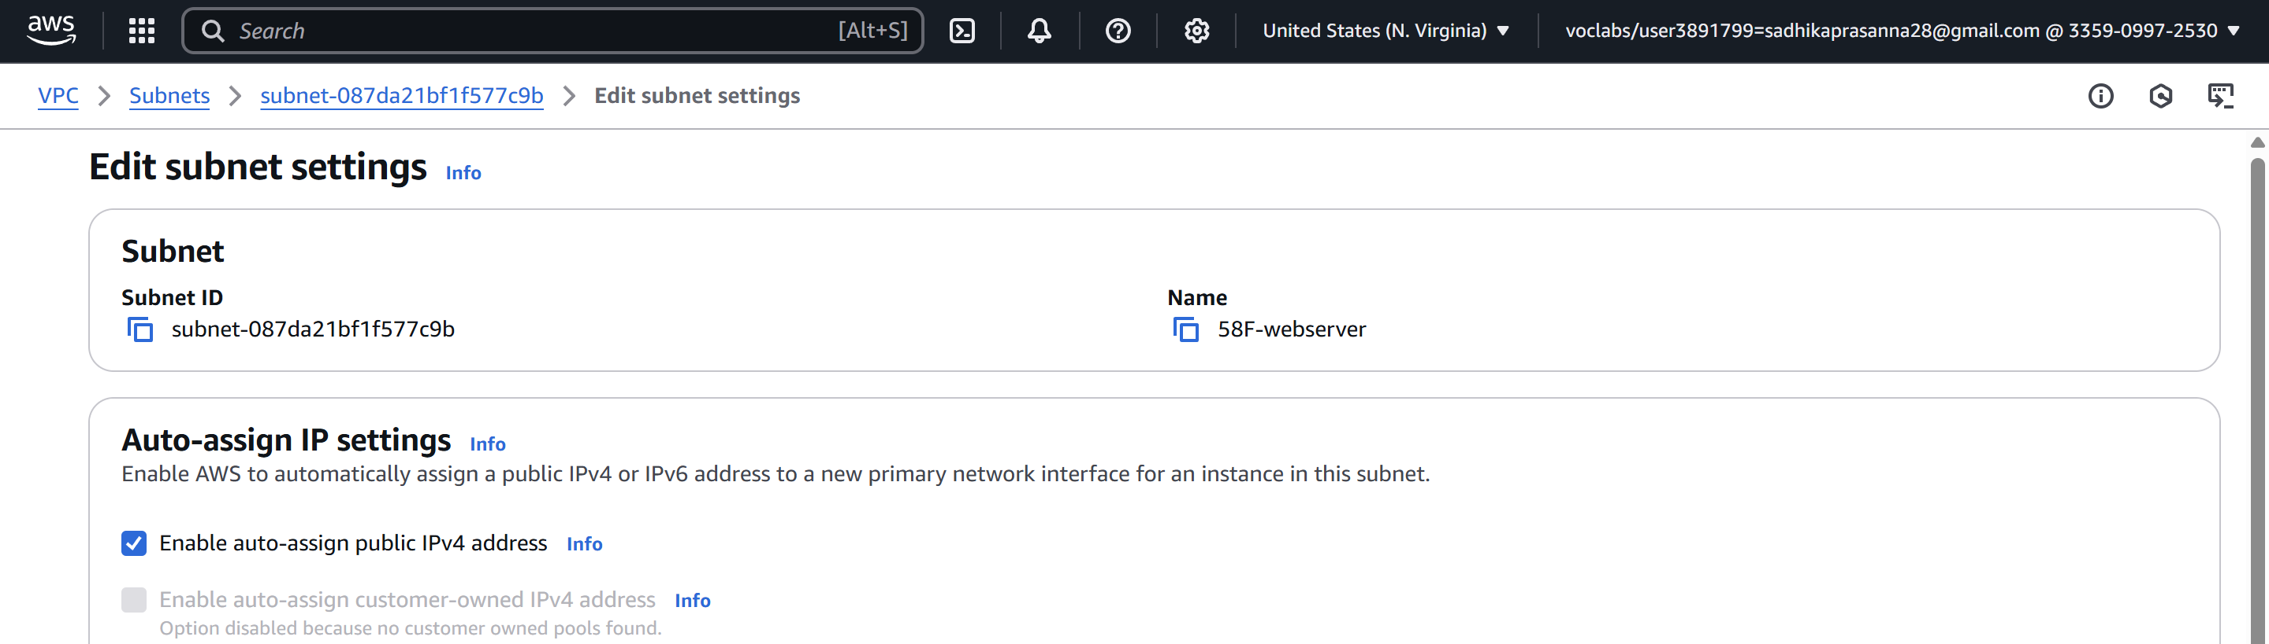

**Create the RT and attach to the public subnet and IGW**

Go to Internet Gateways in the left panel of VPC -> Create Internet gateway

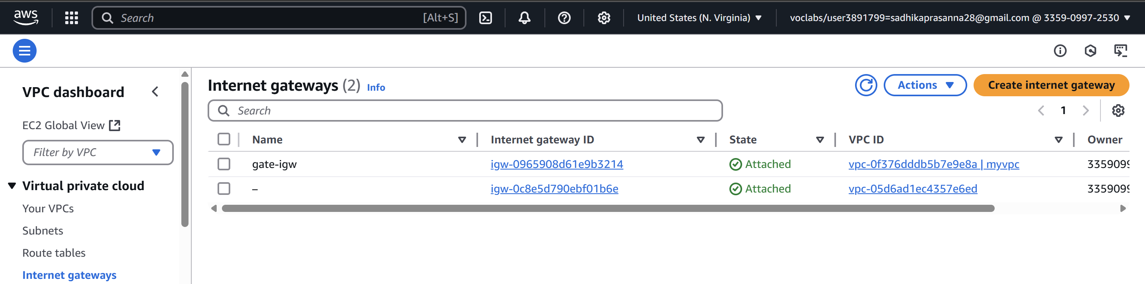

Give name as gate-igw -> Create Internet group

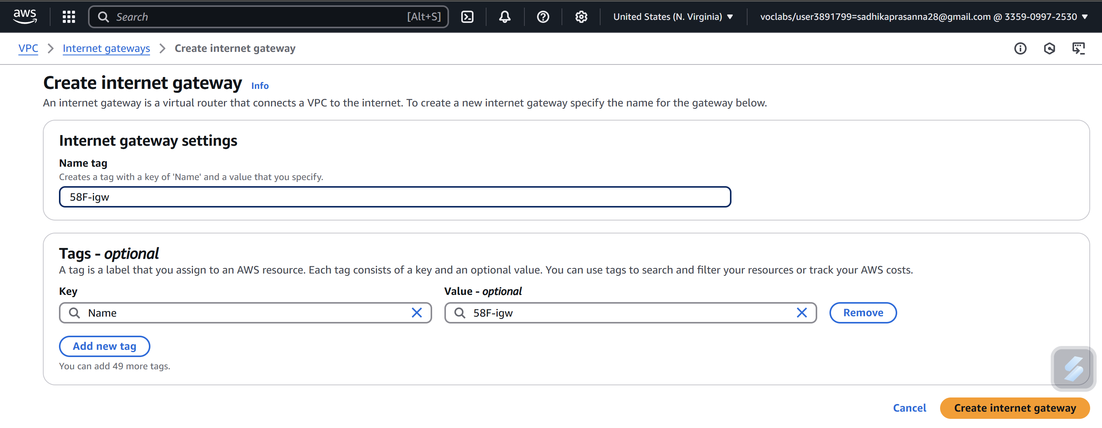

Successfully created Internet Gateway

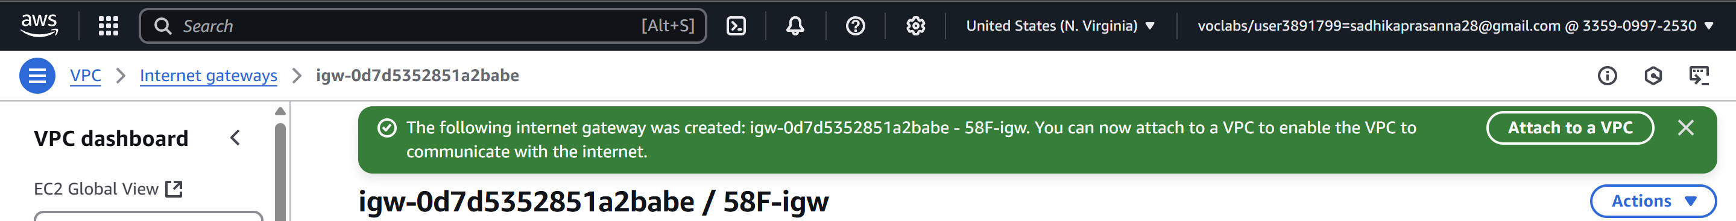

Go to Actions -> Attach to VPC

Select VPC (myVPC) -> Attach Internet Gateway

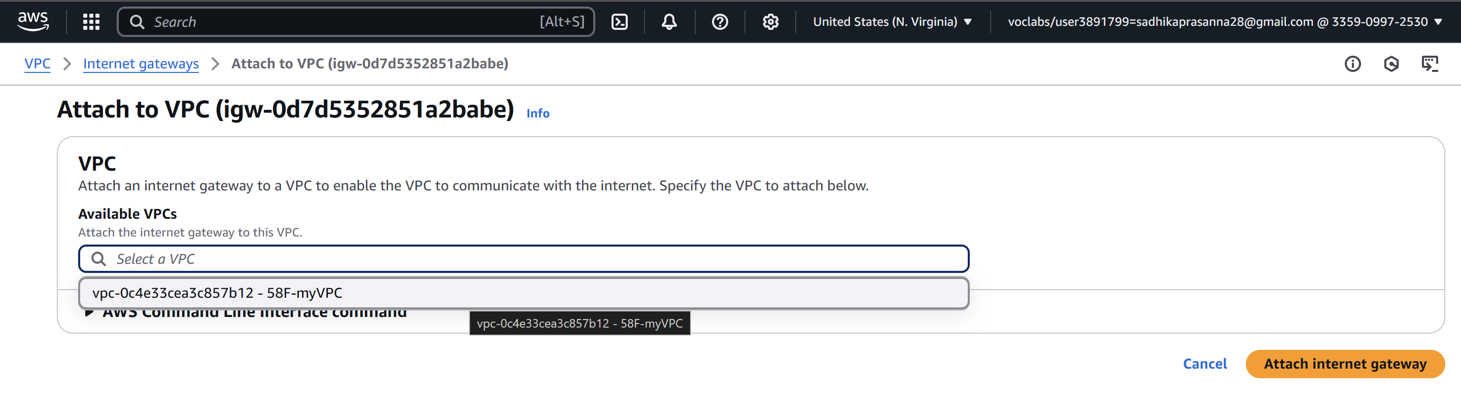

Successfully attached VPC

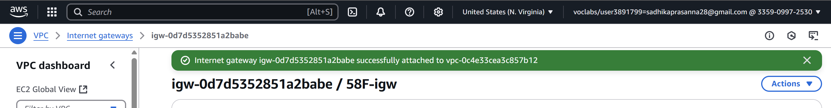

Go to route tables in left panel of VPC -> Create route tables

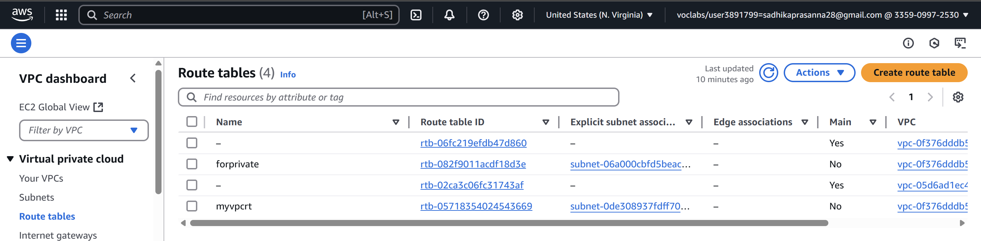

Give name as myvpcrt and select the VPC -> Create route table

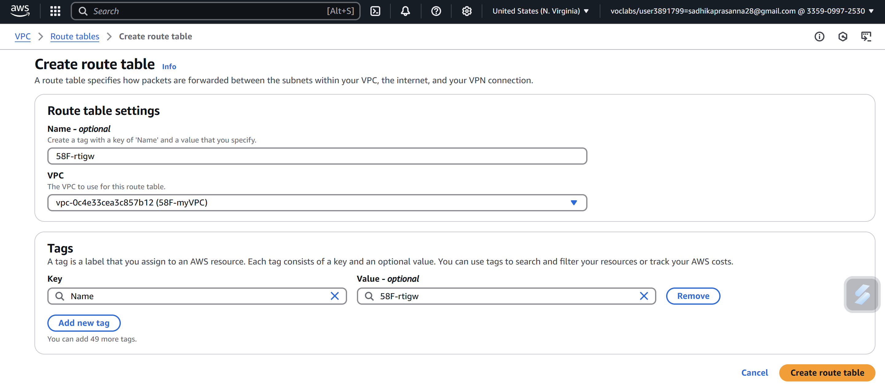

Go to Actions -> Edit subnet associations

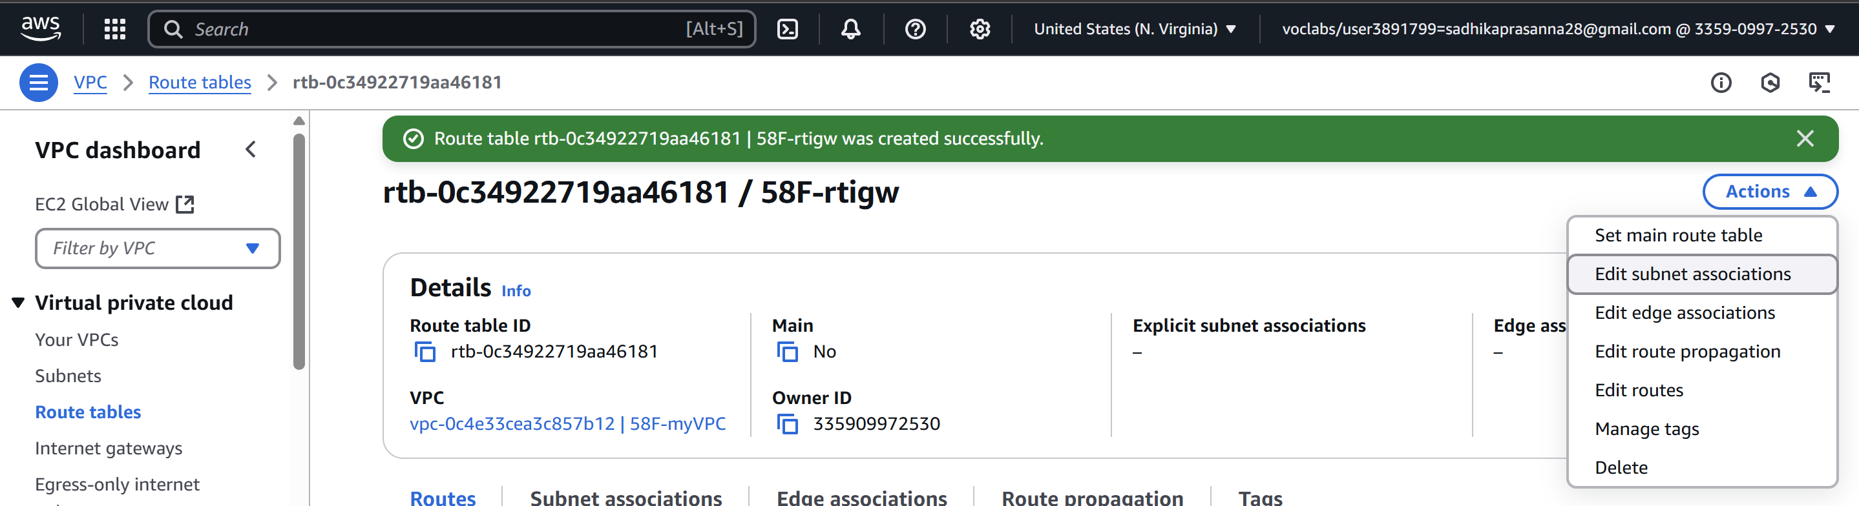

Select 58F-webserver -> save associations

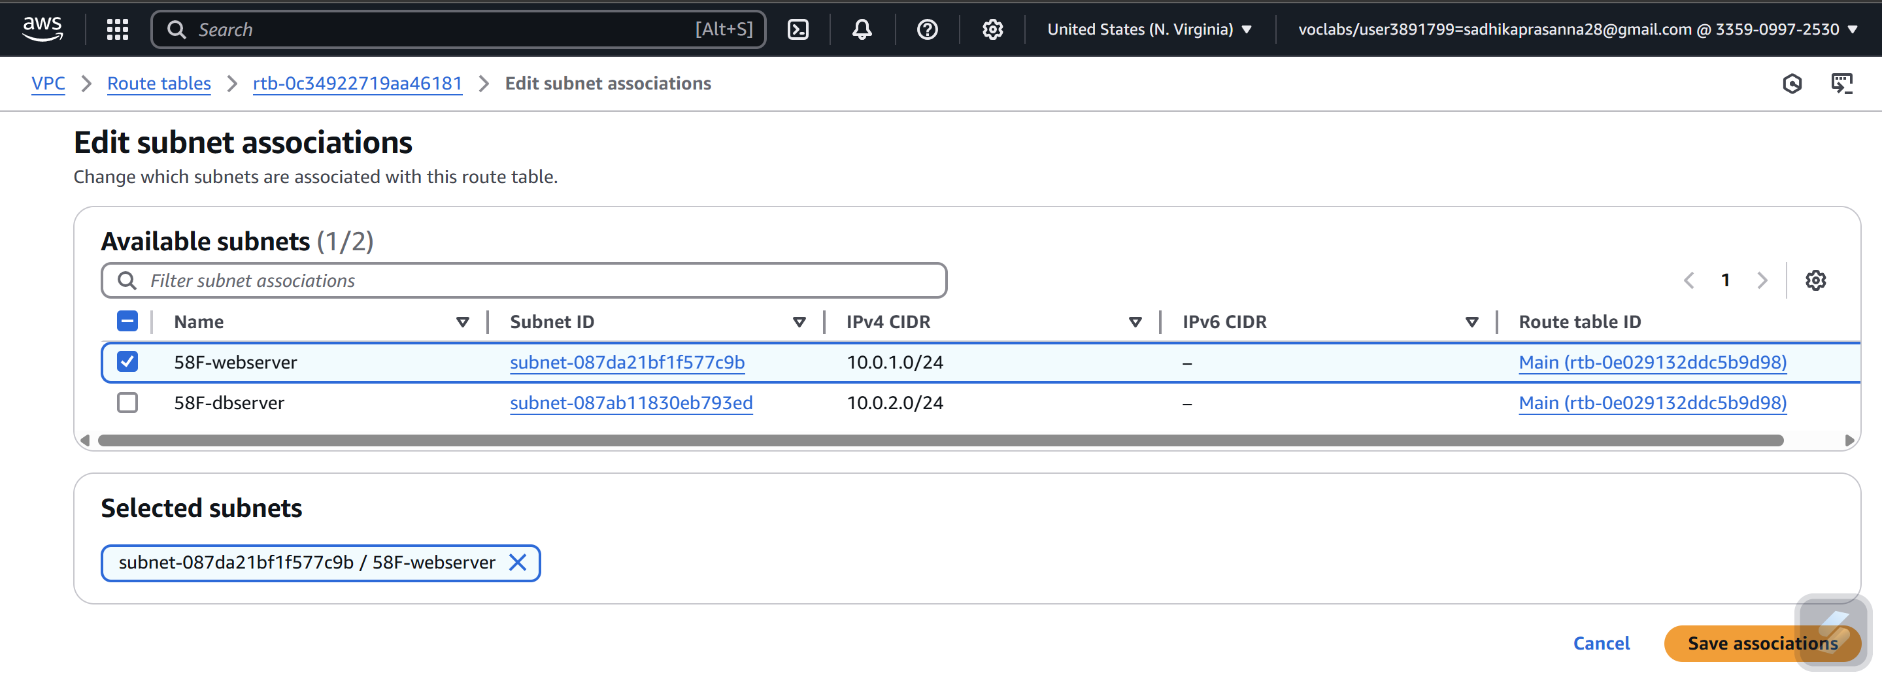

Successfully updated subnet associations -> Go to Edit routes

Give Destination 0.0.0.0/0 and target select Internet Gateway (gate-igw) -> Save Changes

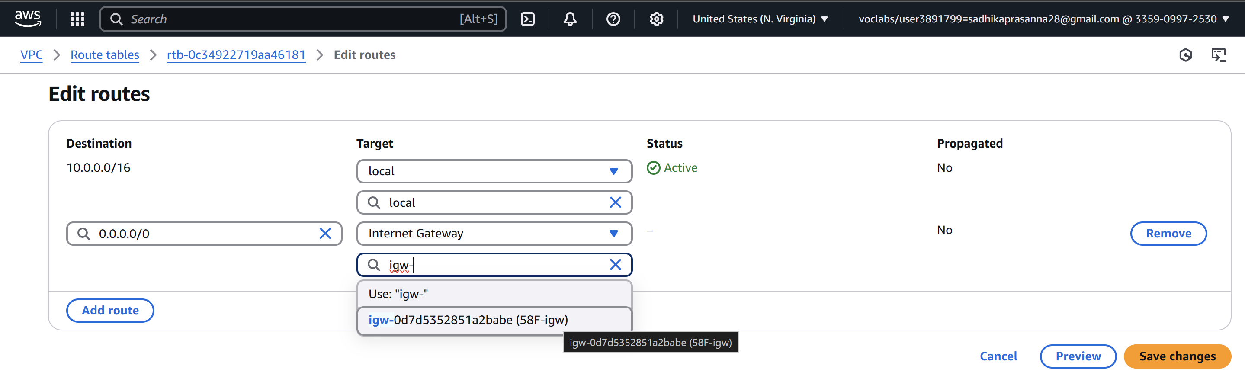

Updated routes successfully

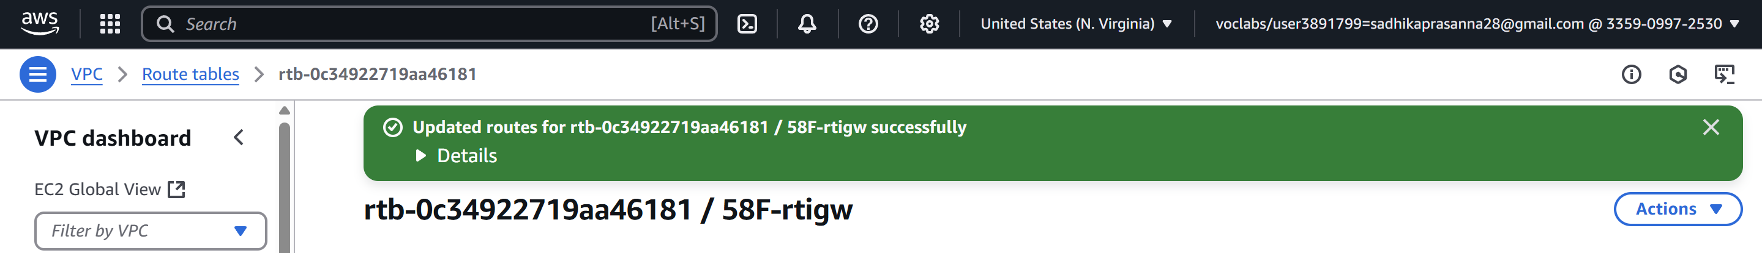

**Create virtual machines in two subnets**

Now create two Virtual machines one in public and other in private subnet

1. Webserver in public subnet

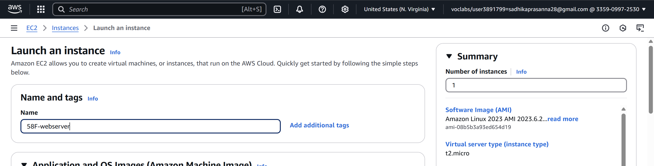

Select key-pair

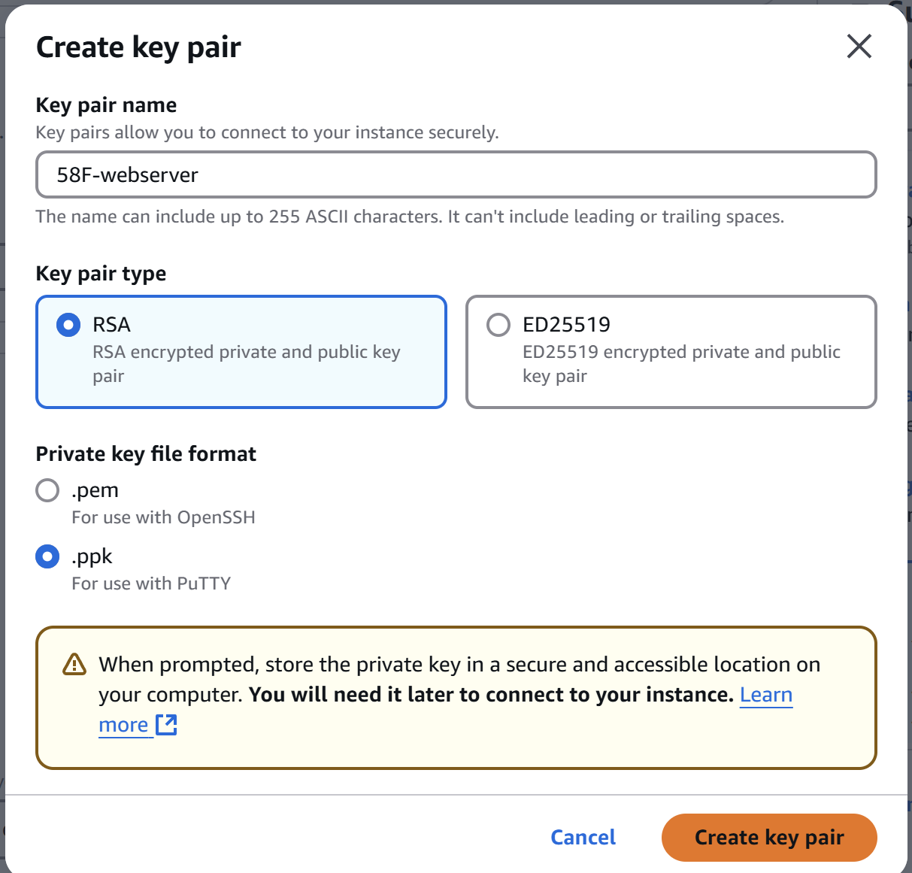

Select VPC (myVPC) and subnet public (webserver)

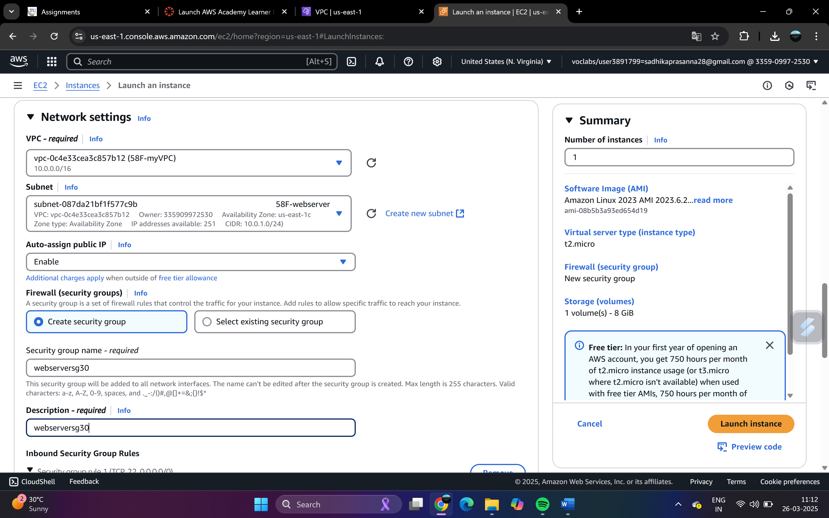

Create security group -> webserversg30 -> Launch instance

Create another virtual machine dbserver

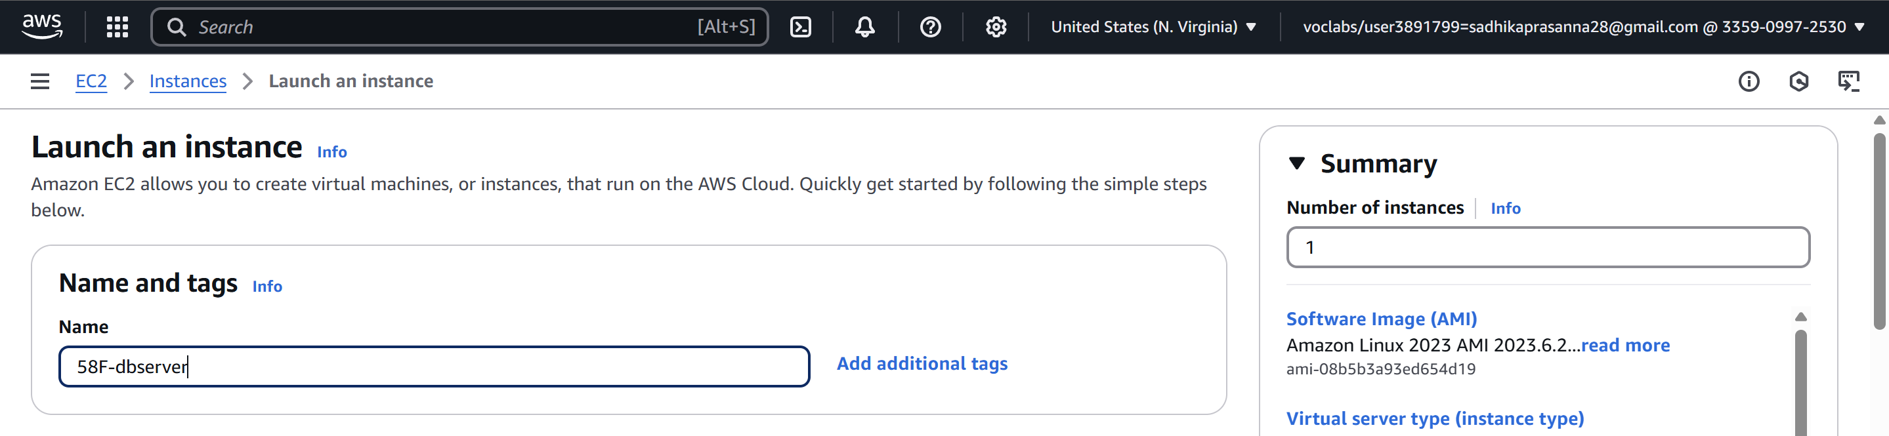

Select key-pair

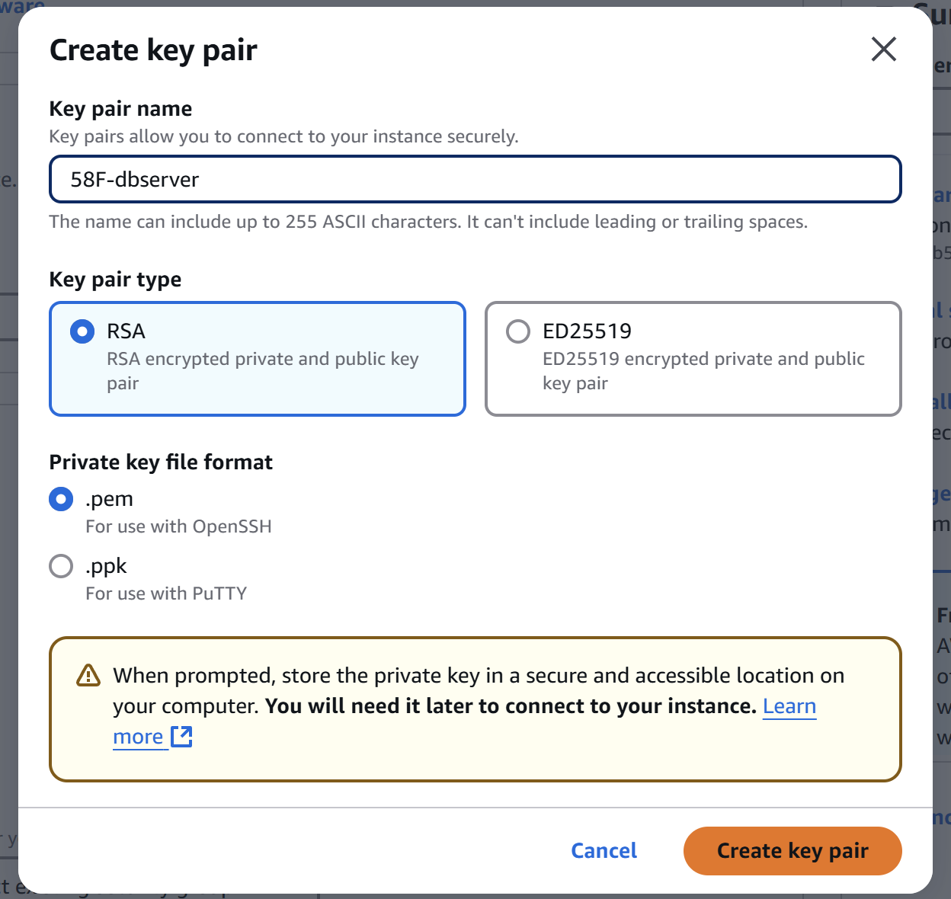

Create security groups

Select VPC(myVPC) and subnet as dbserver

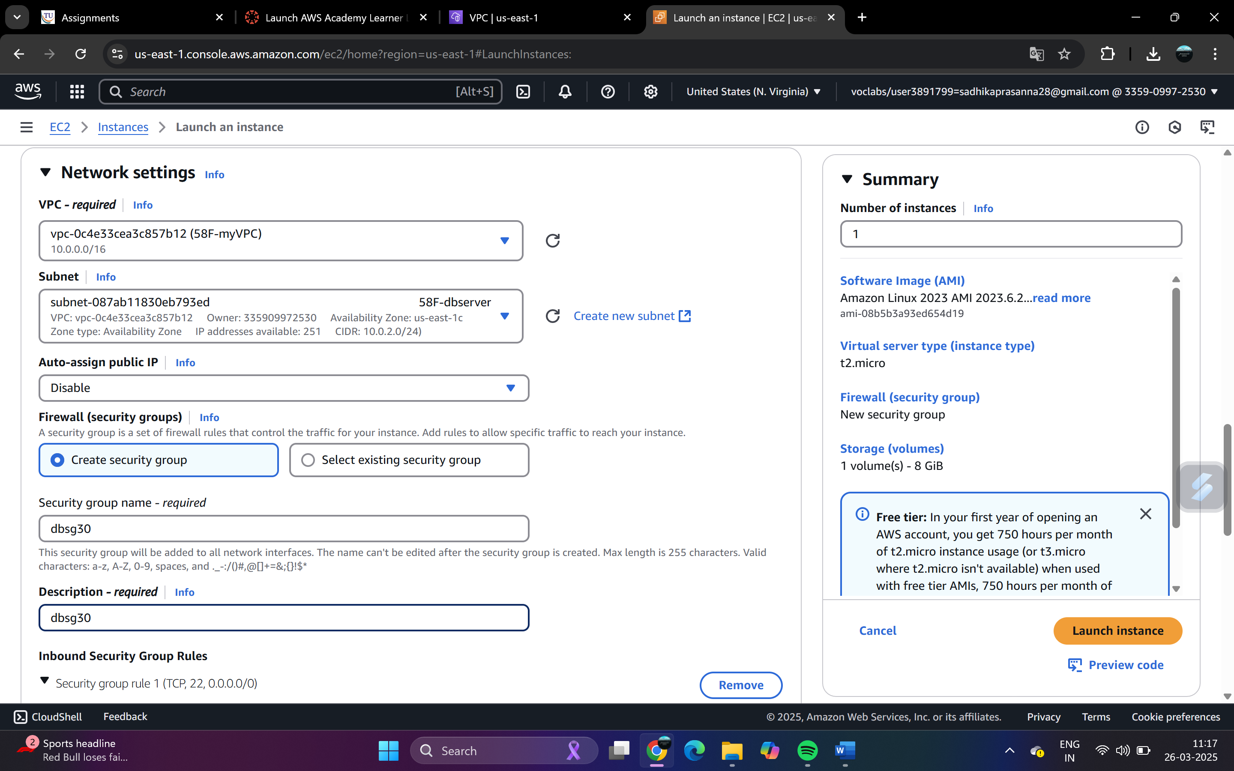

Add security group rule: Type->MYSQL/Aurora Source:10.0.1.0/24

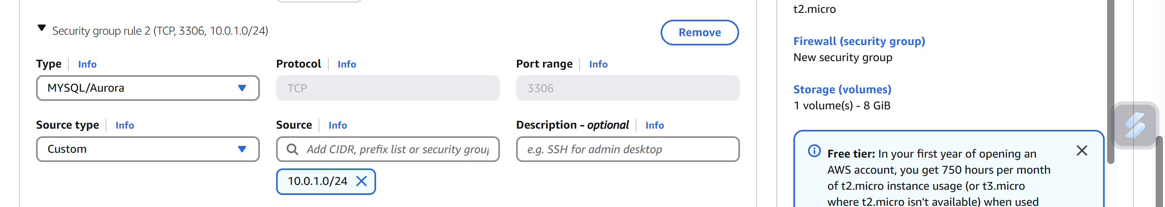

Now, Only I can connect to Bastion server through SSH

From the Bastion server, I should able to jump into Dbserver.

That means, DbServer SSH port should be open to Bastion server.

Goto Dbserver security group - DbSG30 ( new tab )

Select DbSG -- Inbound --Edit

Add Rule

Type Source

SSH Custom 10.0.1.24/24 ( Private IP of bastion server)

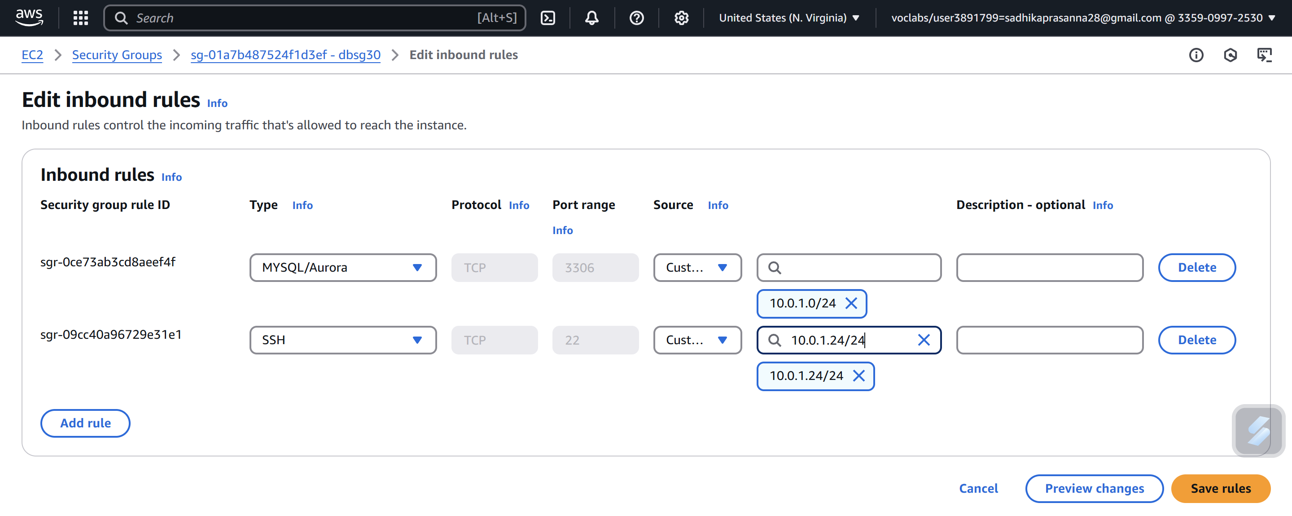

Create new Instance Name: 58F-bastionserver

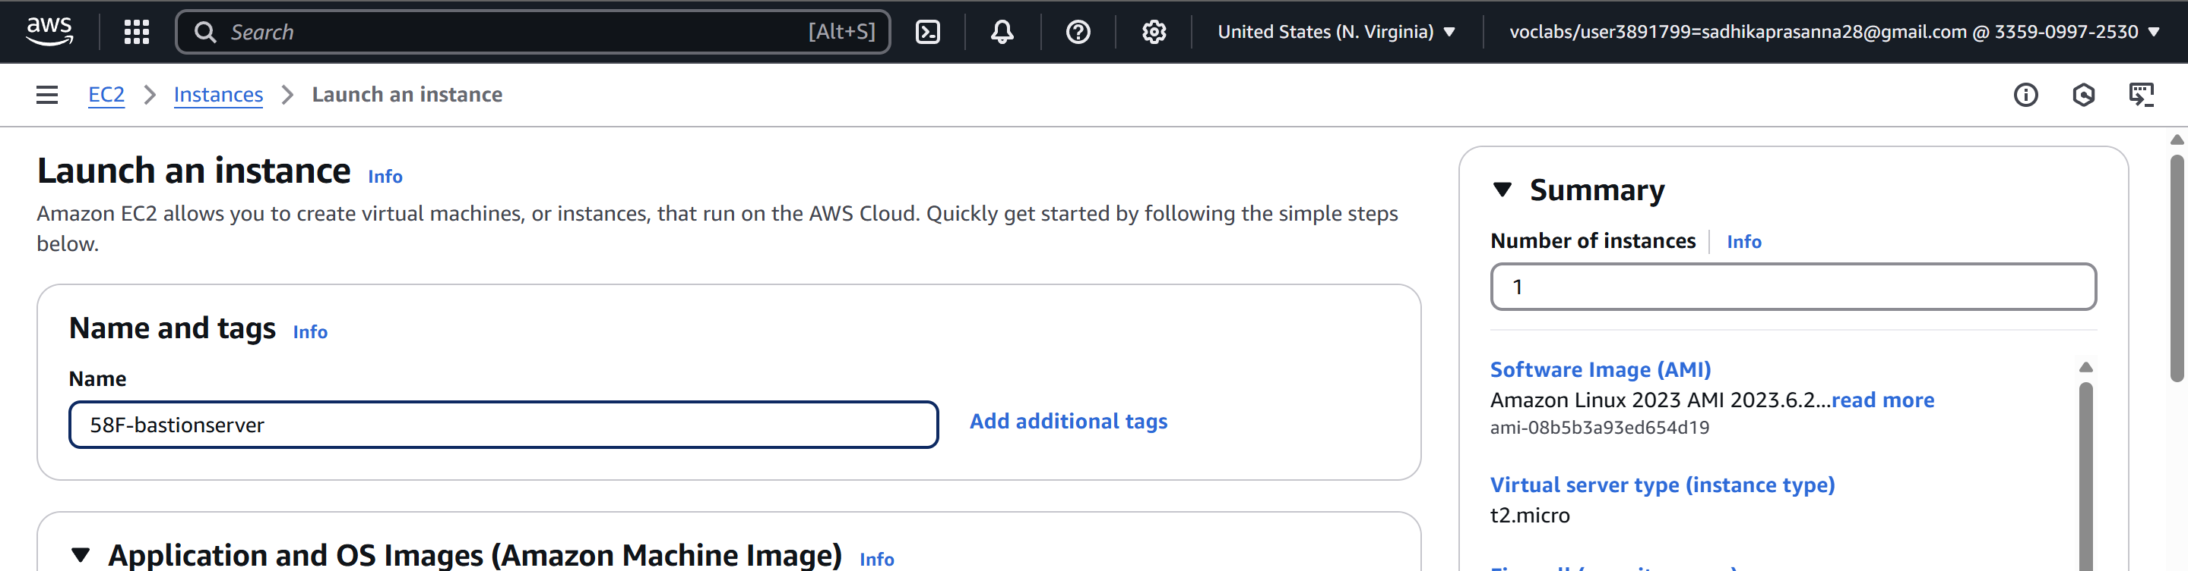

Security Group: BastionSG30

Description: BastionSG30

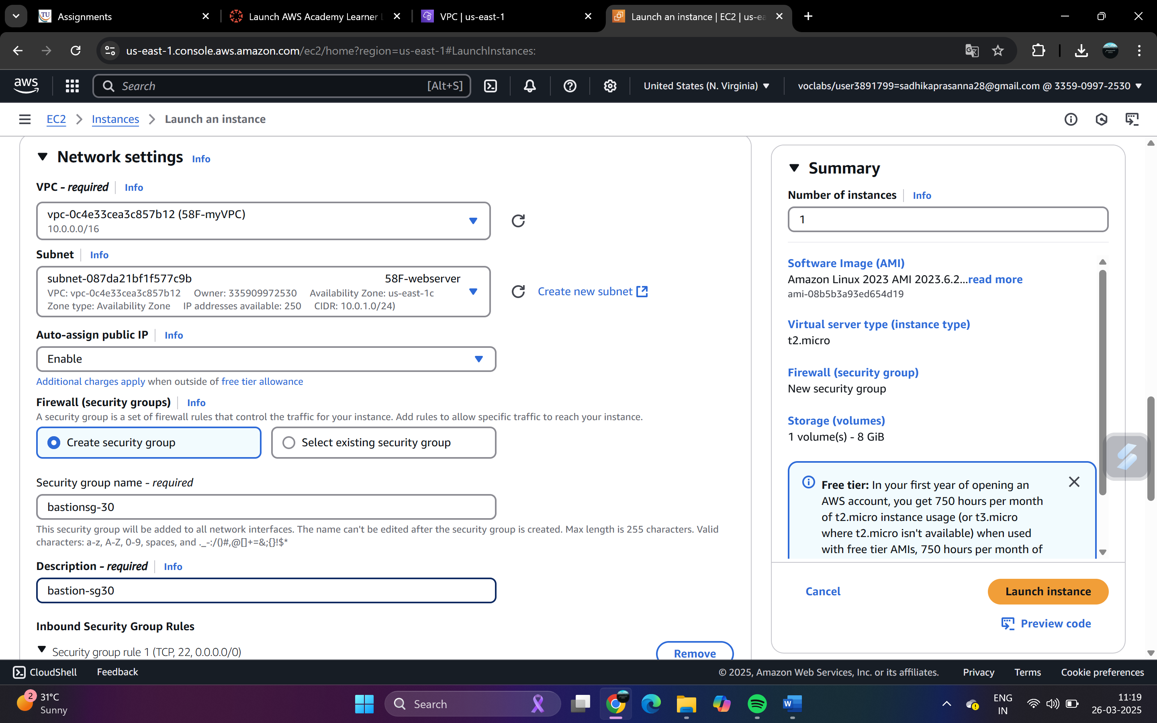

(SSH port -- should be open to myself)

Type Source

SSH My IP

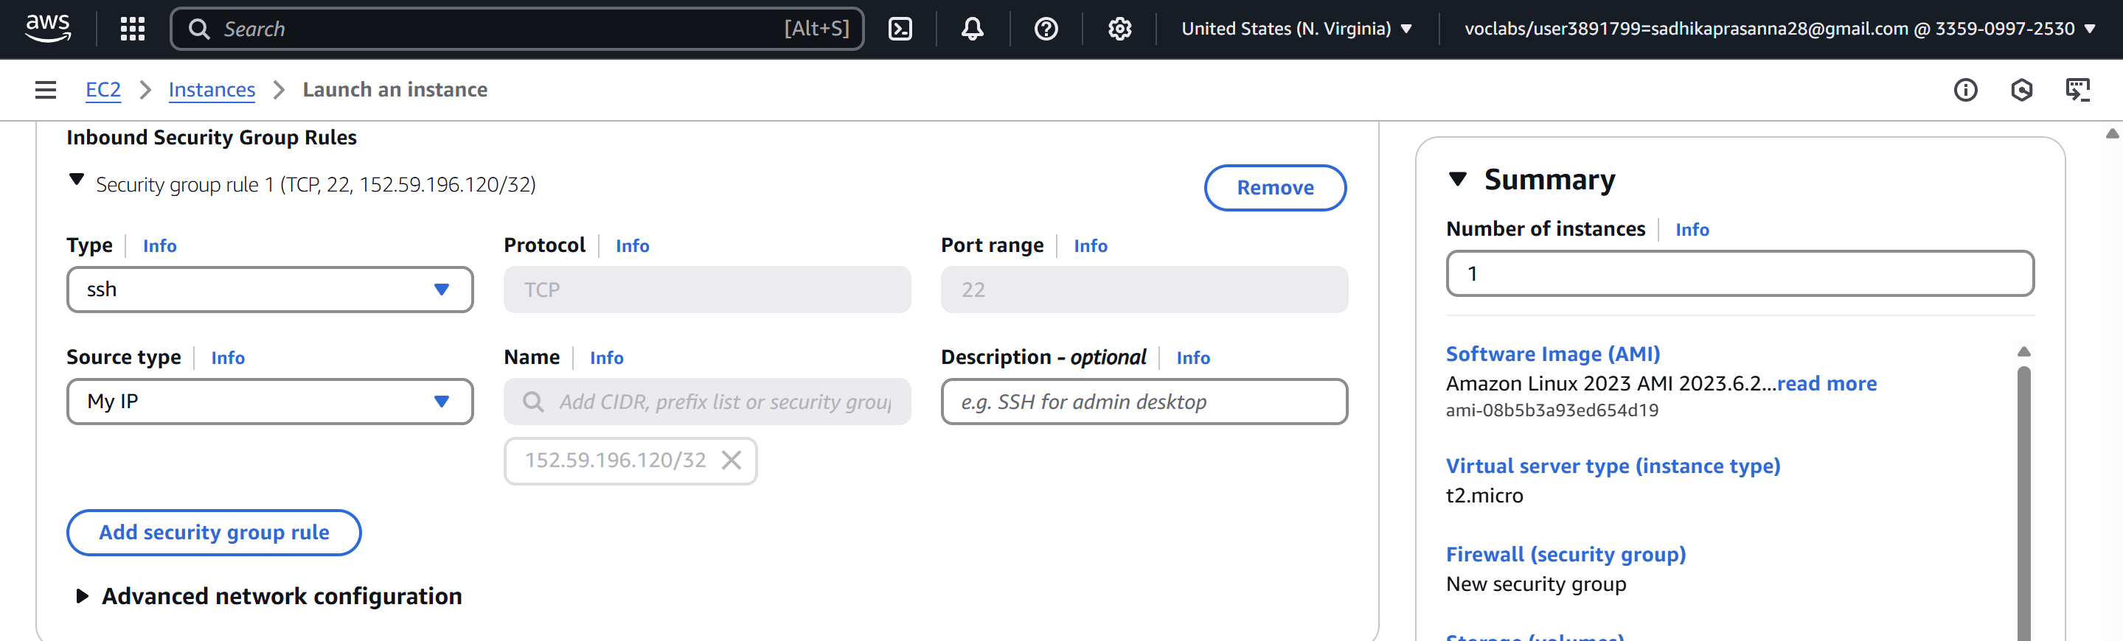

Review and launch -- launch

View Instances-> Select 58F-bastionserver

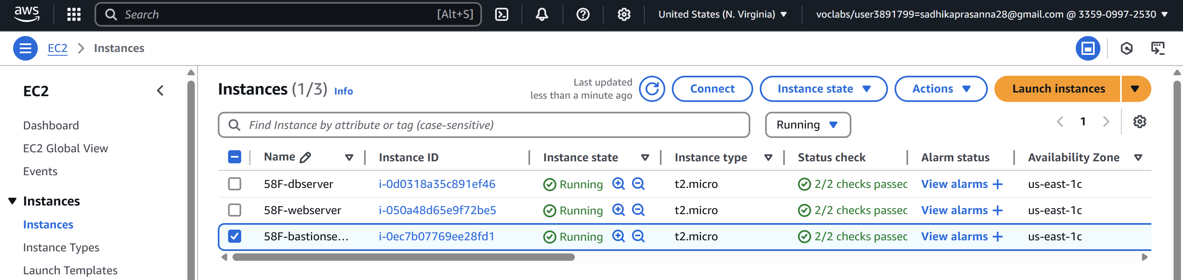

Connect to instance -> Through putty

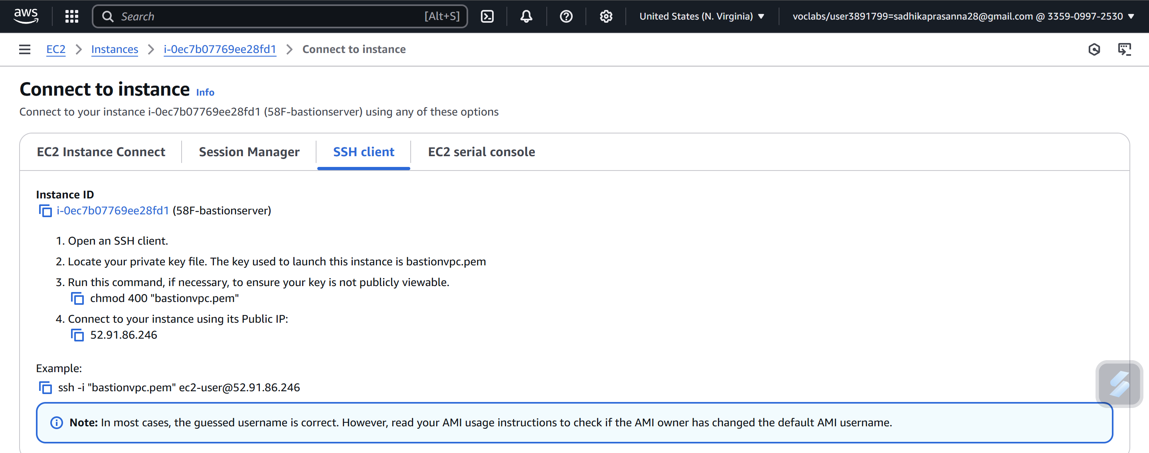

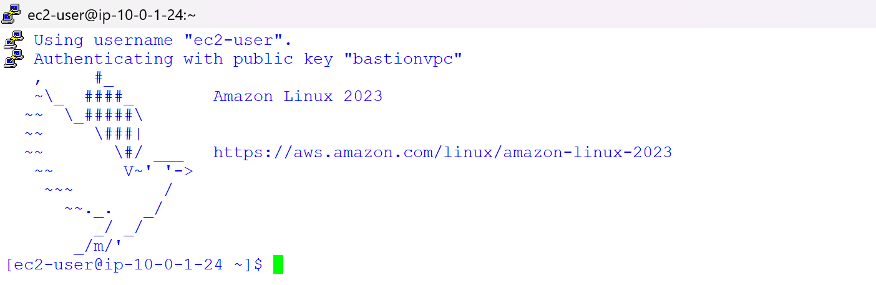

Now open WinSCP ->Copy the Host name

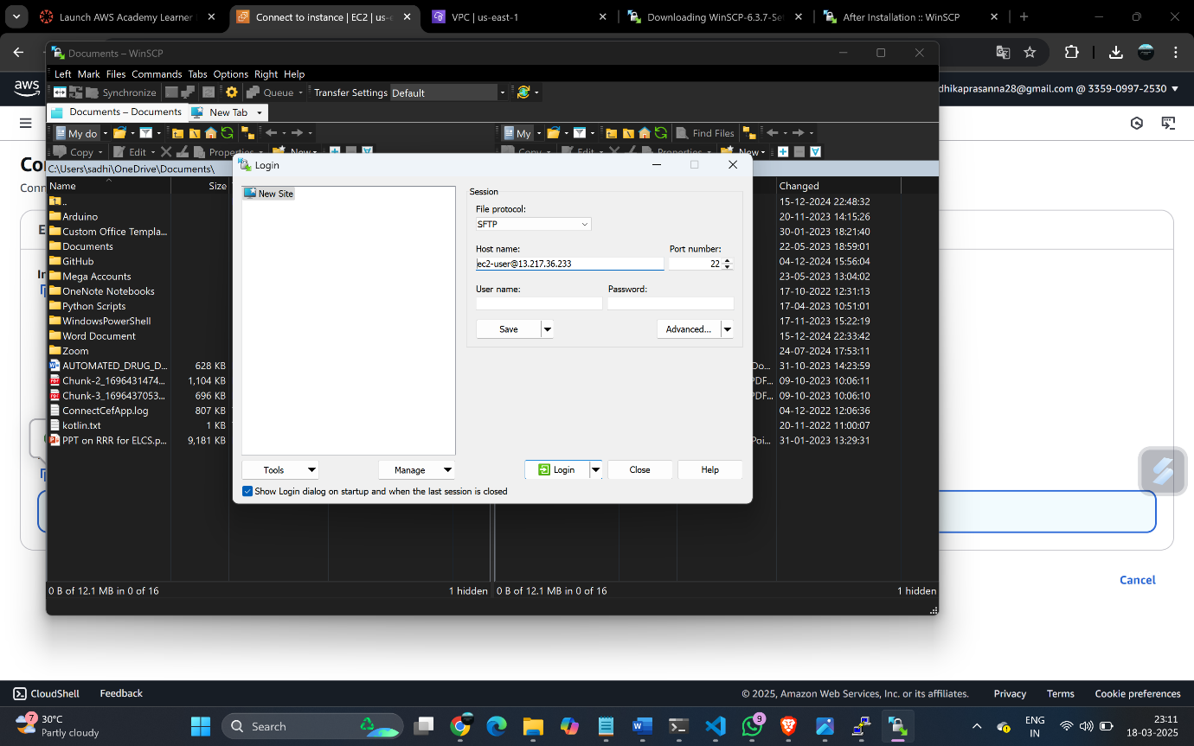

Browse BastionServer .ppk

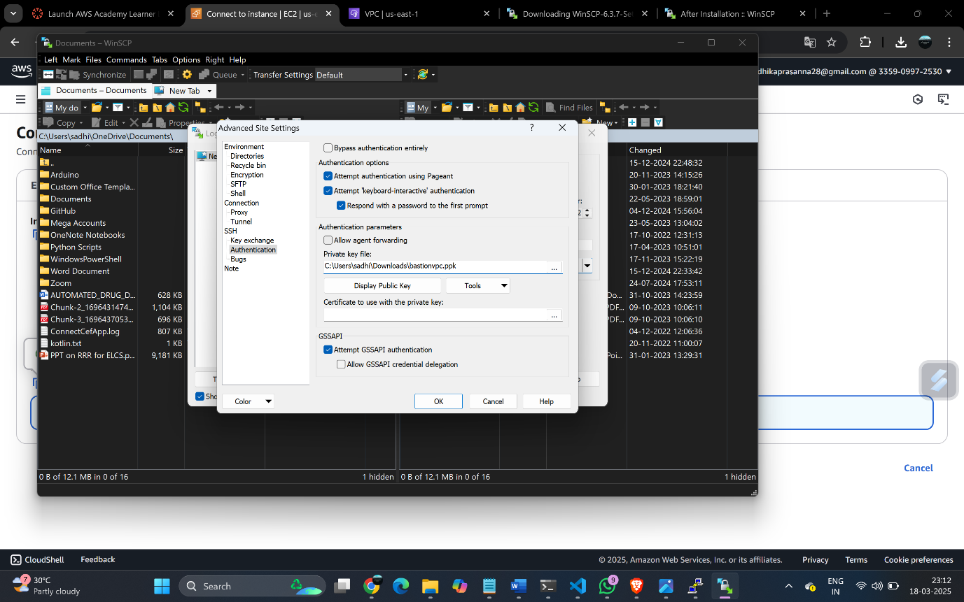

Accept then it will connect to dbserver through bastionserver the pem of dbserver is pasted

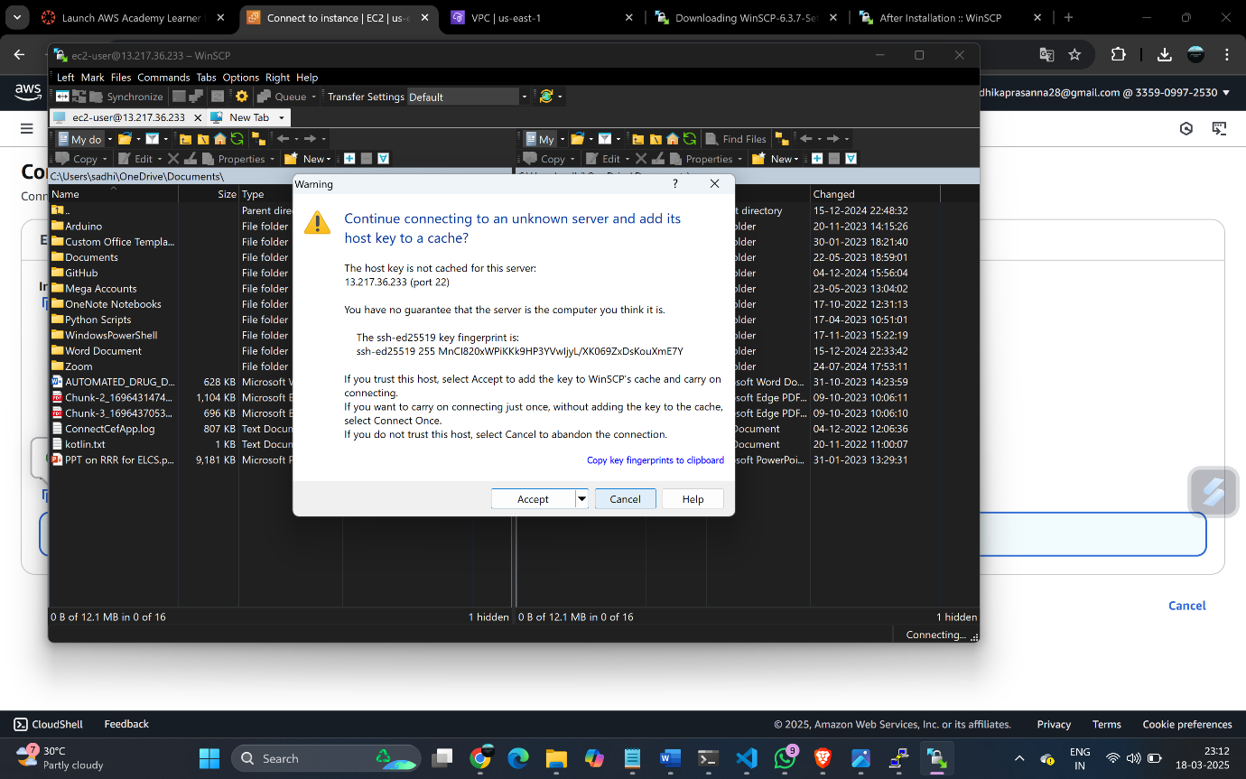

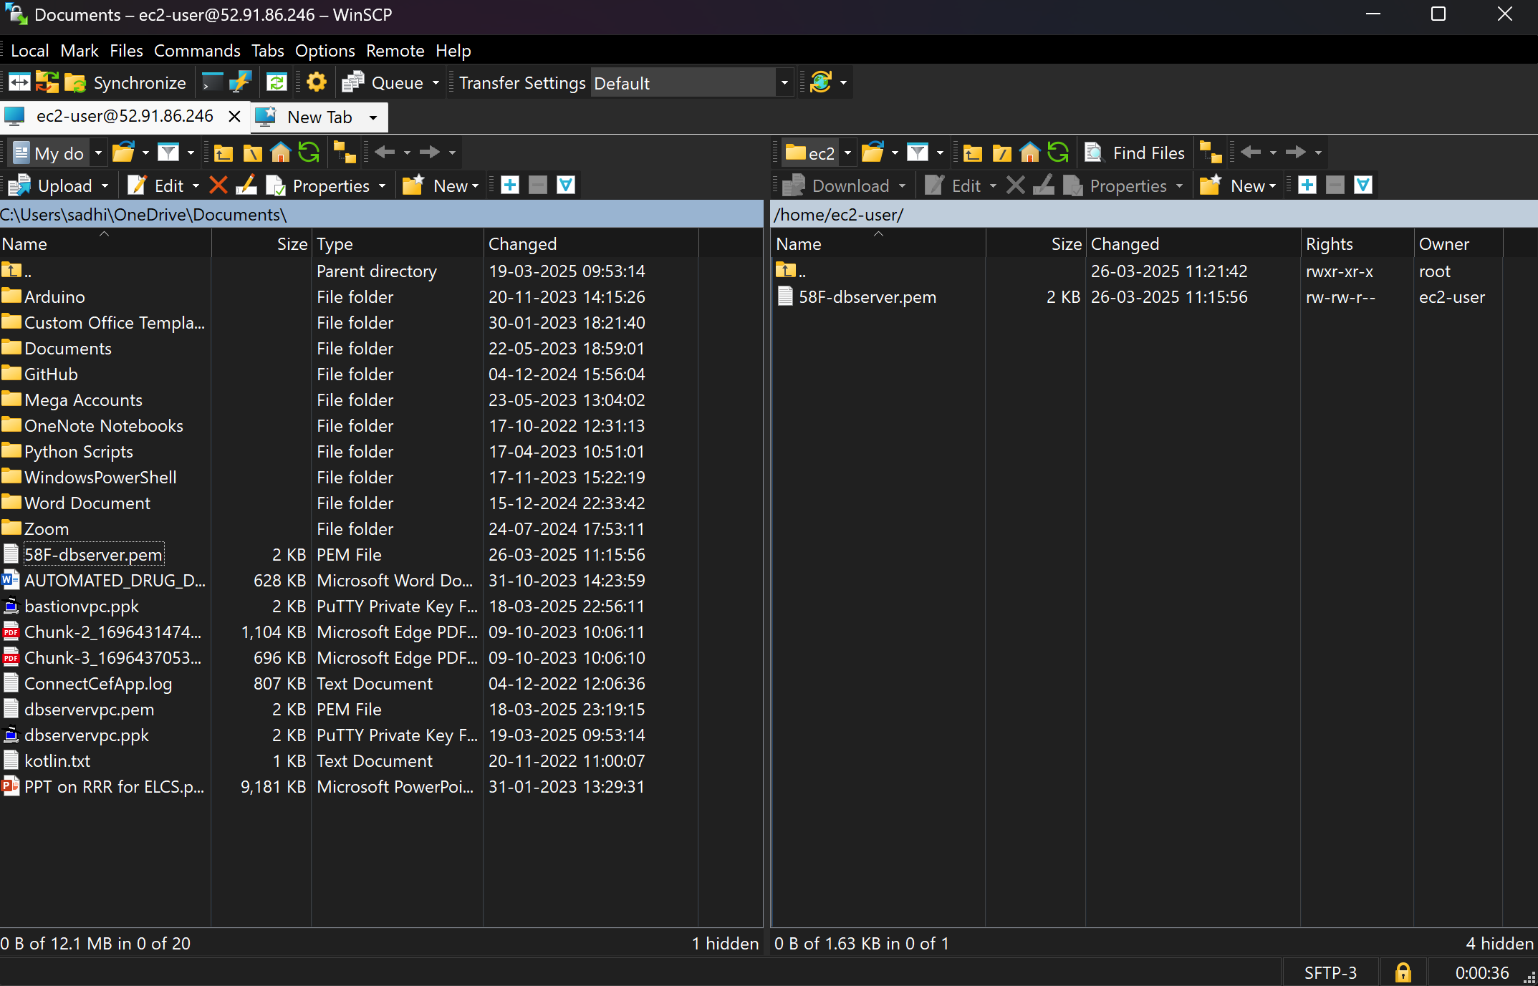

Now in putty check ls we can see the pem key of dbserver

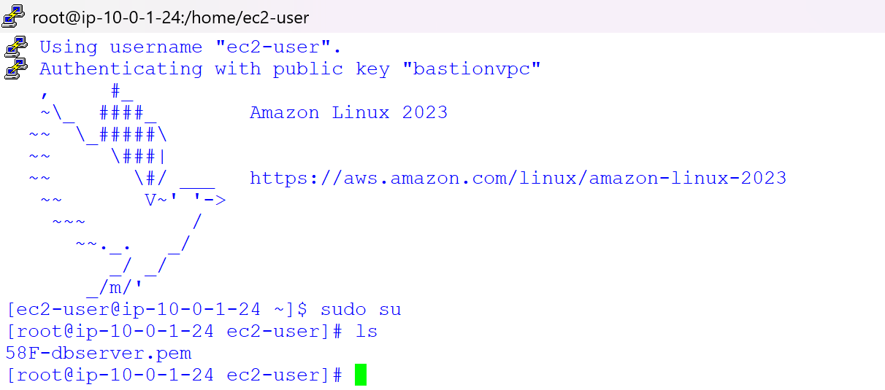

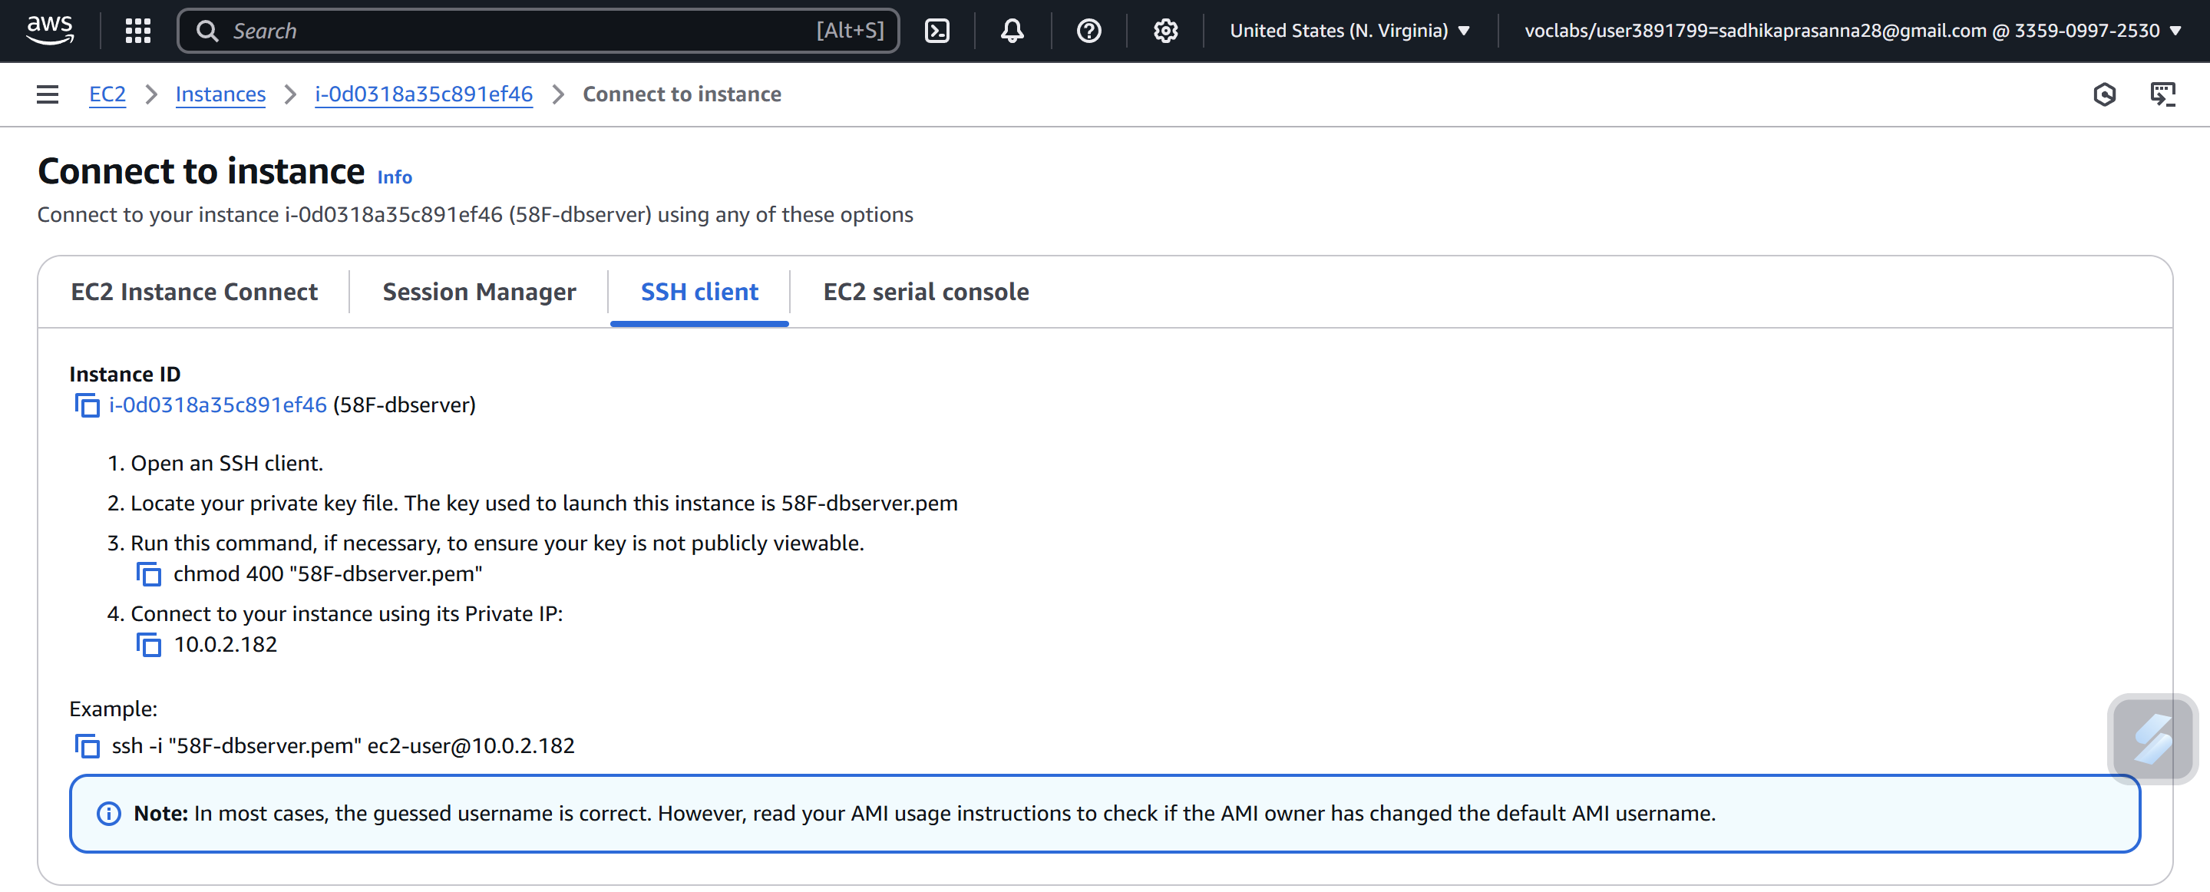

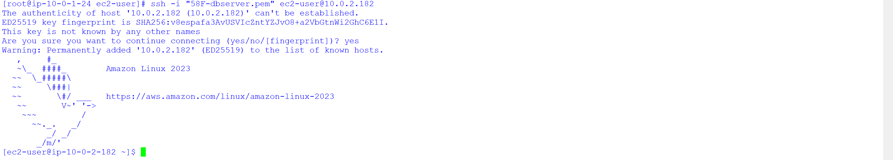

If we try to access internet it will show error



Here we are unable to get internet in the private instance to get the internet in the private instance we have to create a nat gateway which is network address translation

Go to NAT Gateway

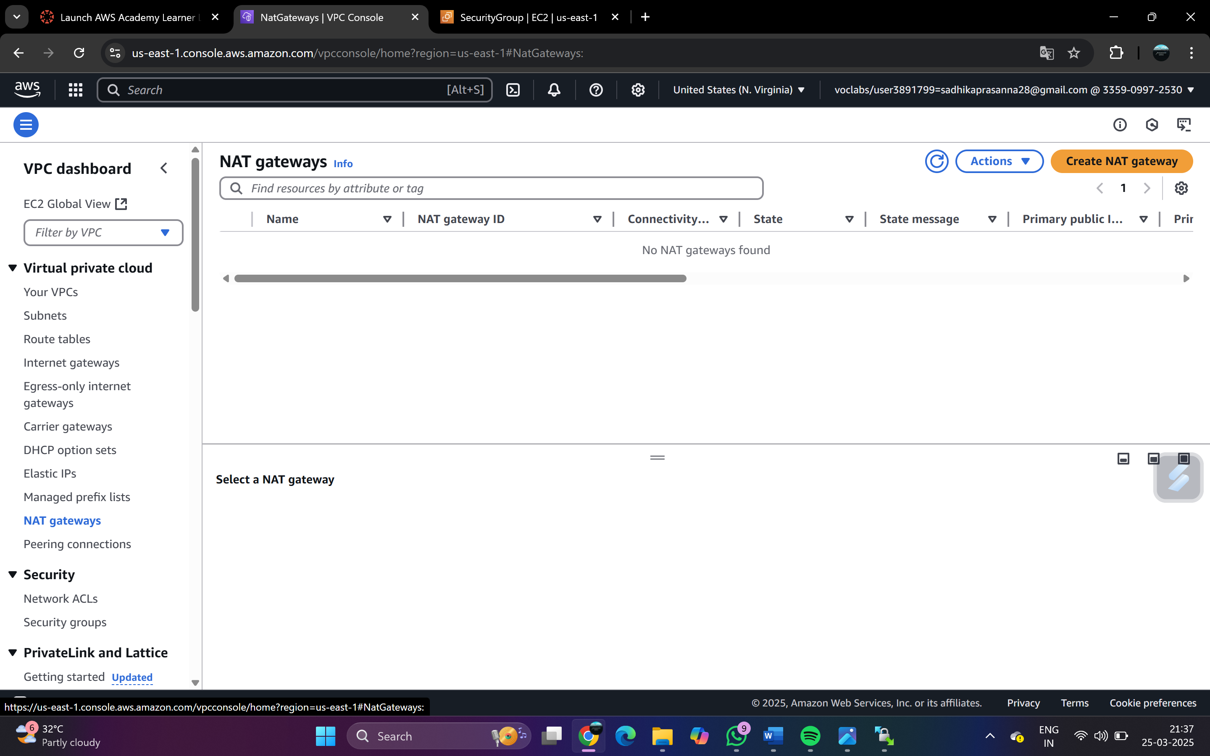

Click on create NAT gateway -> Give a name and subnet which is public and click on create

Select Connectivity type as->Public

Click on Allocate elastic IP

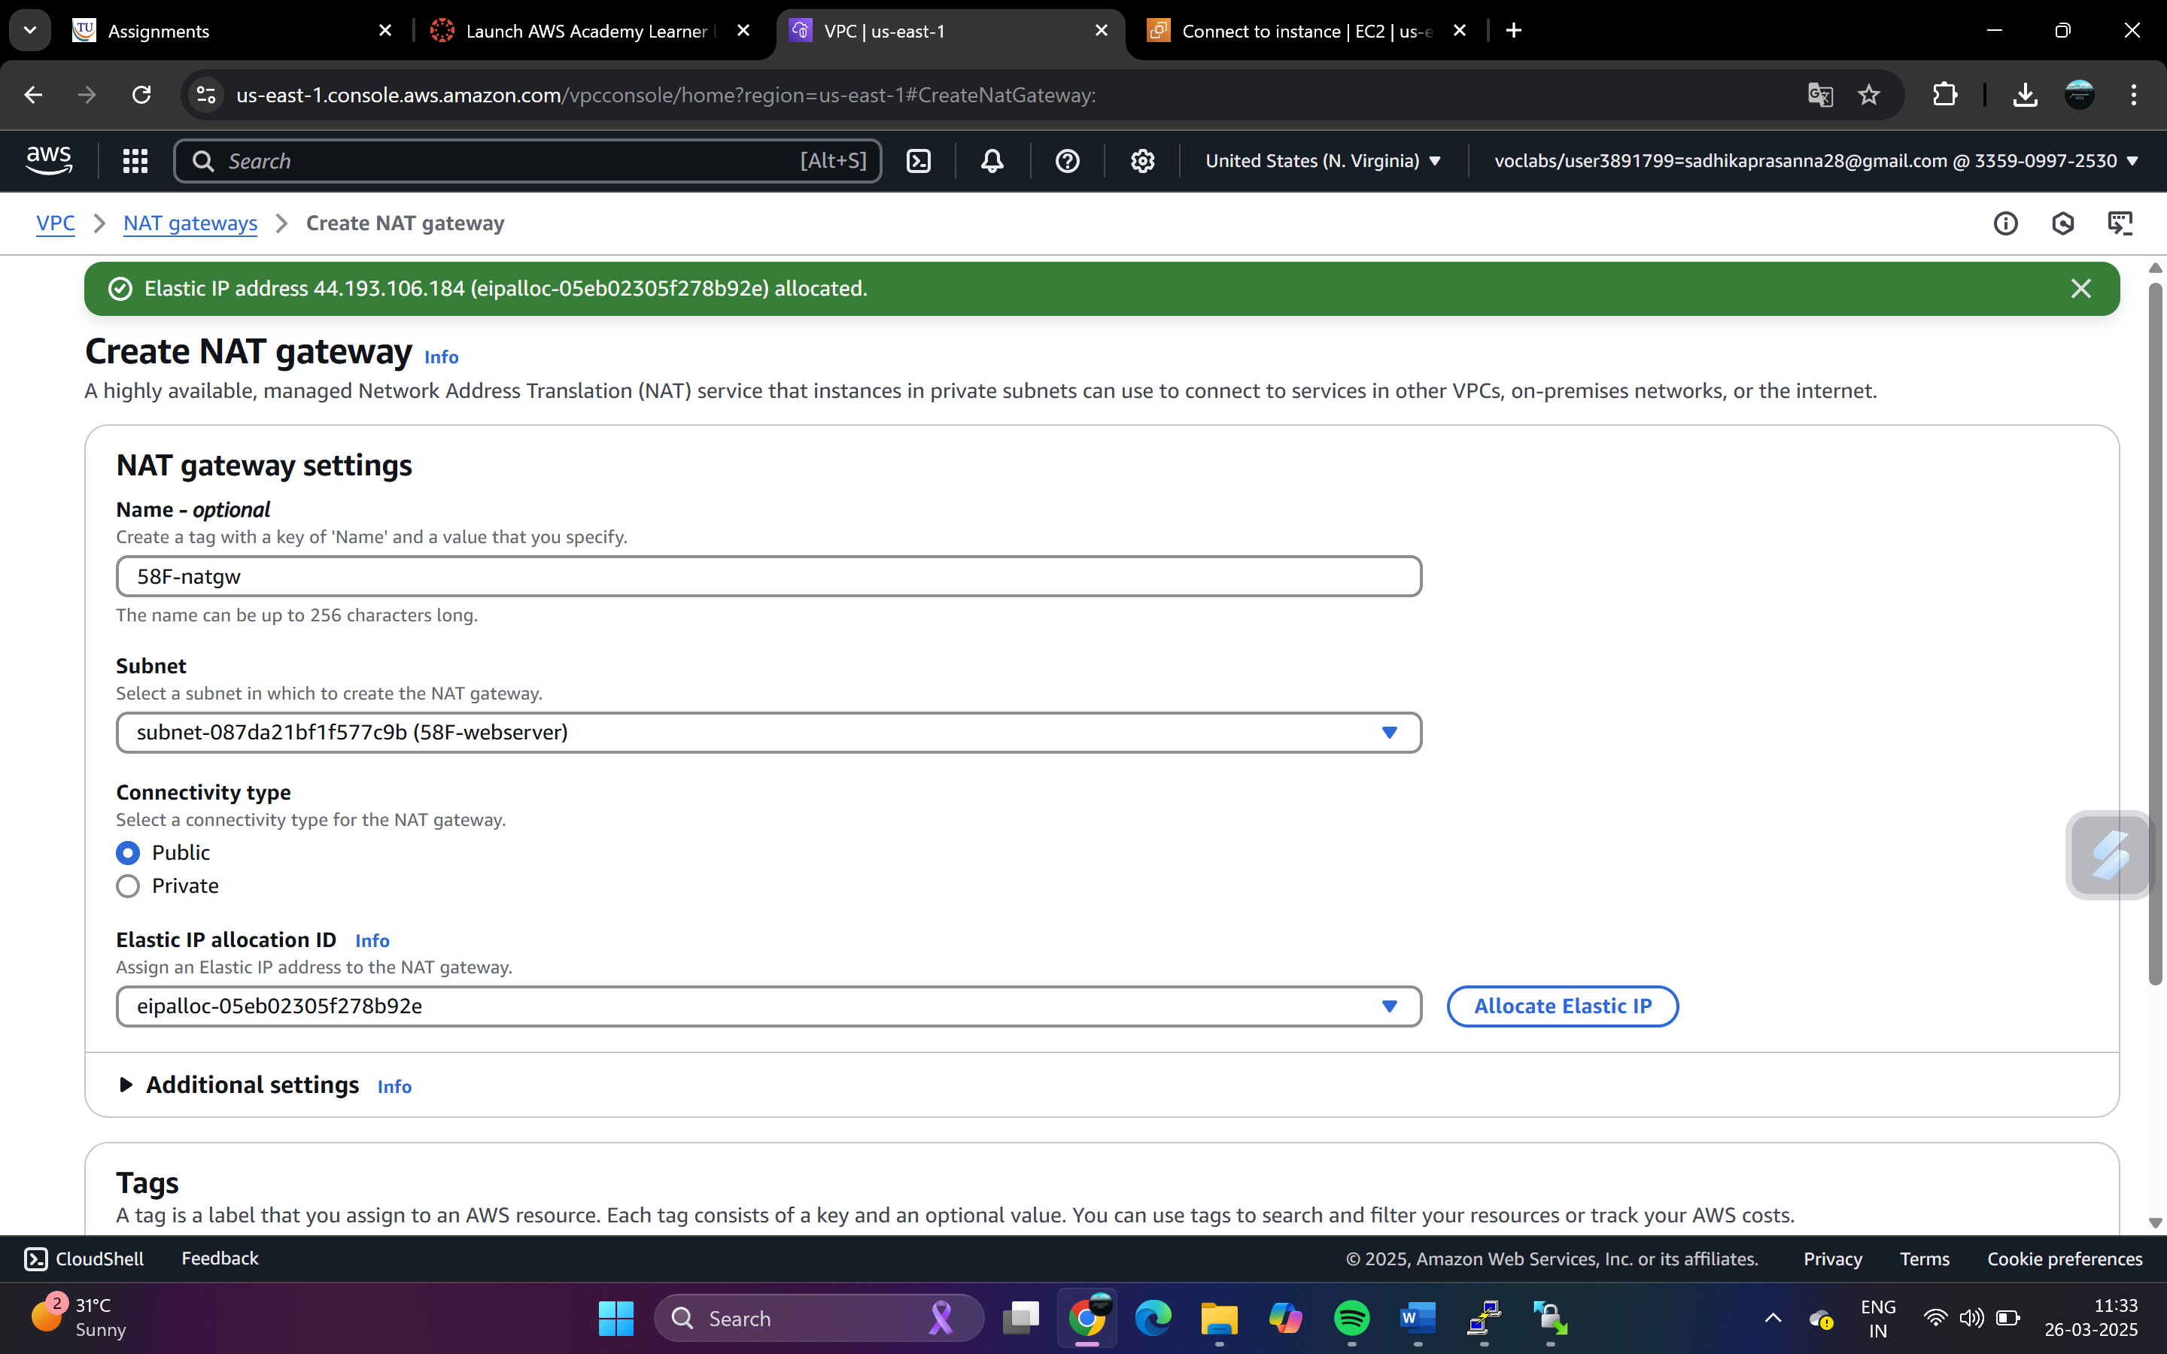

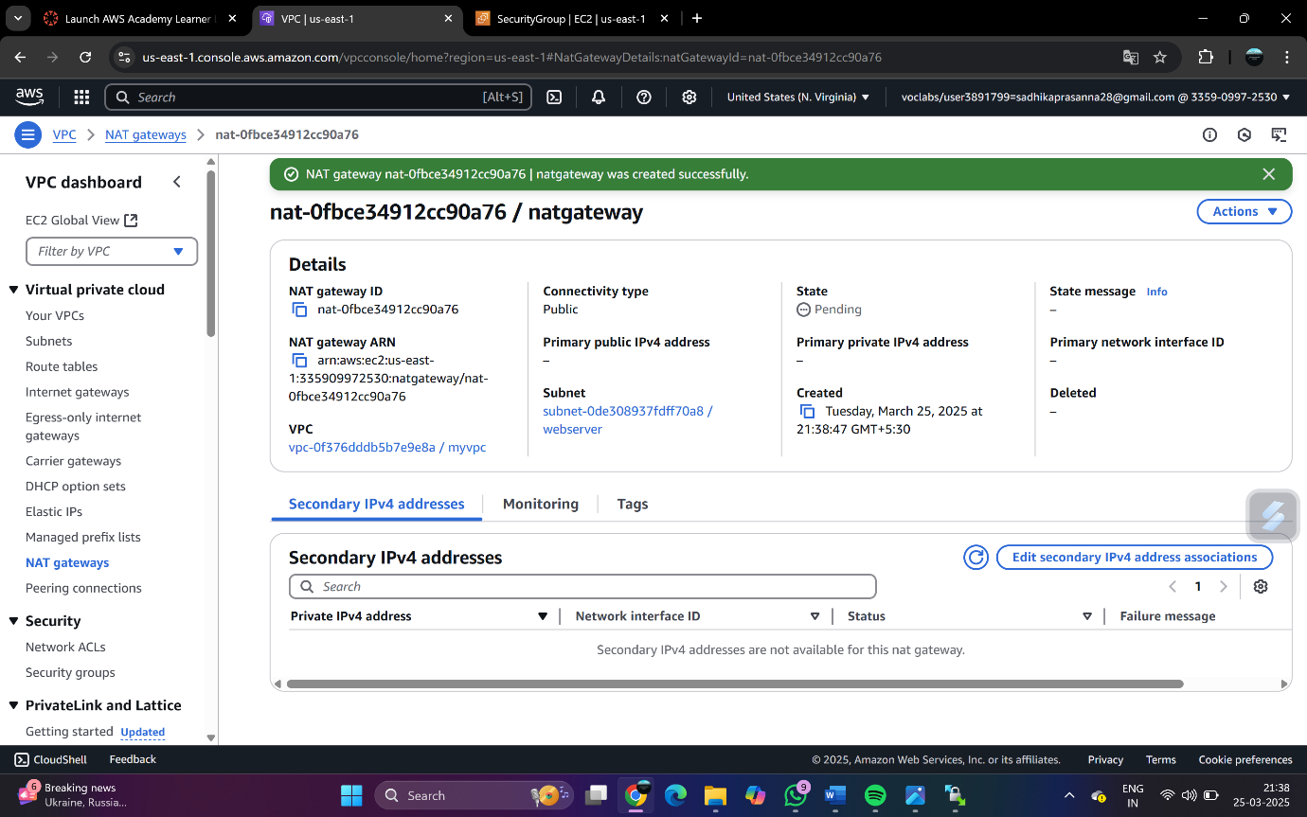

Now go to route tables -> create route table -> name as forprivate

Select the VPC -> myVPC

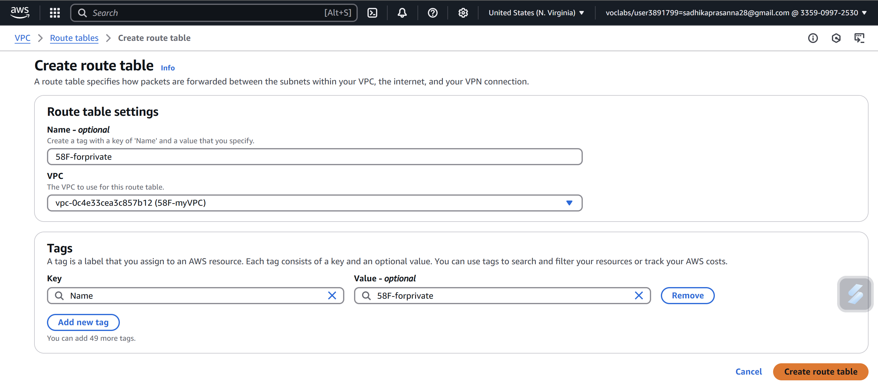

Select -> forprivate route table ->Edit routes

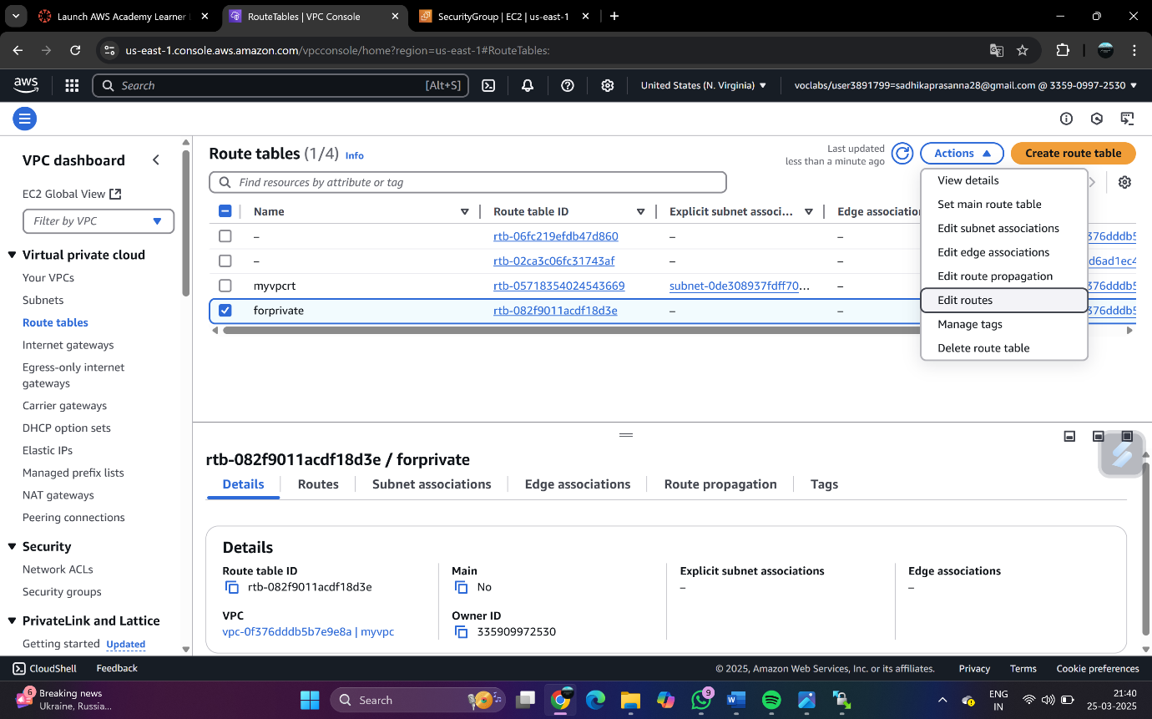

Add NAT Gateway created

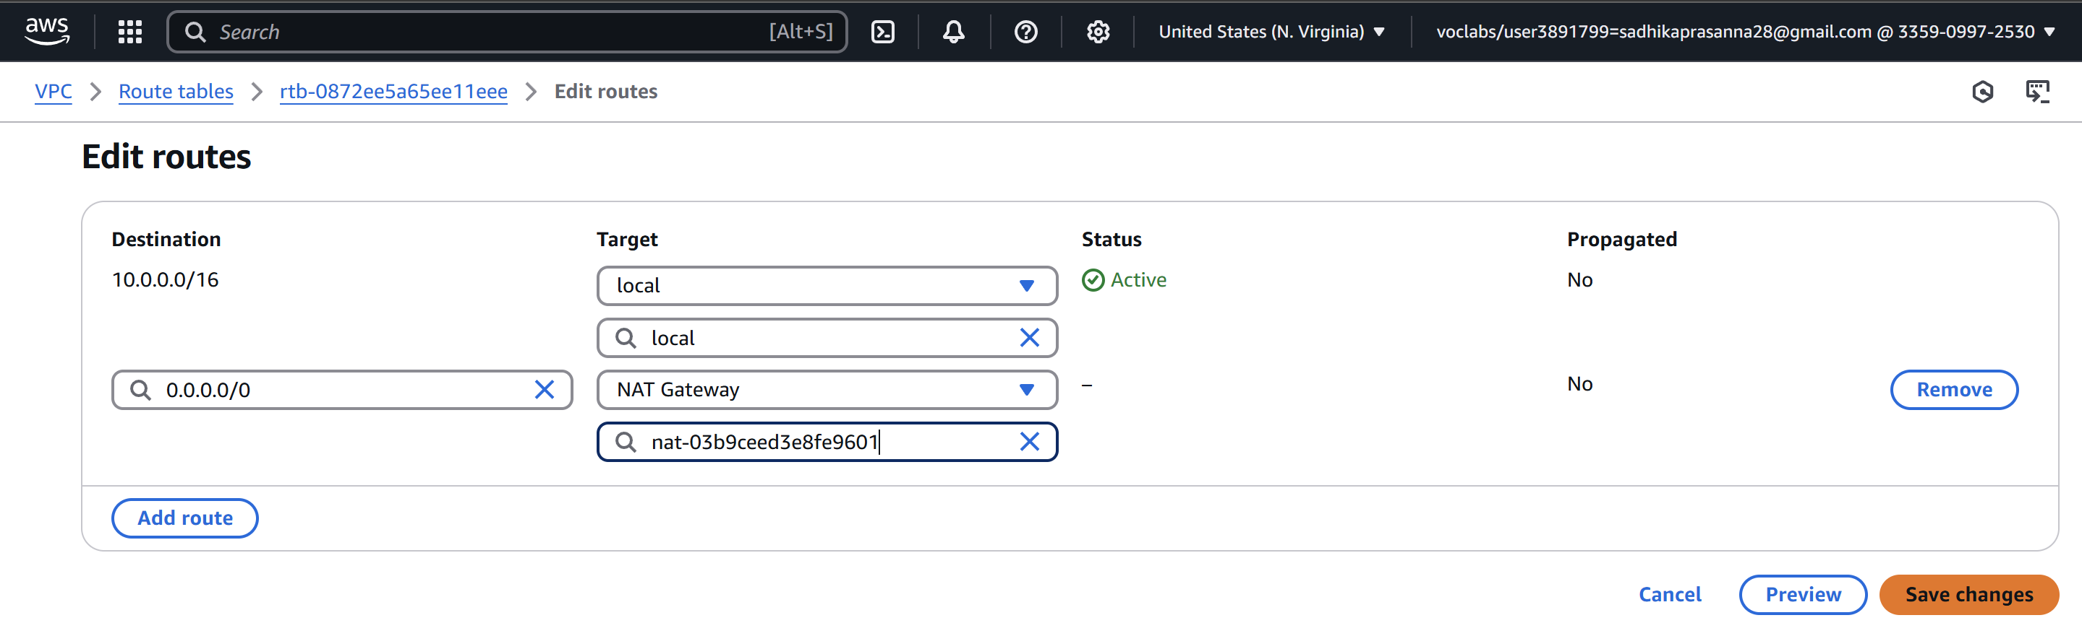

Select forprivate route table -> Edit subnet associations

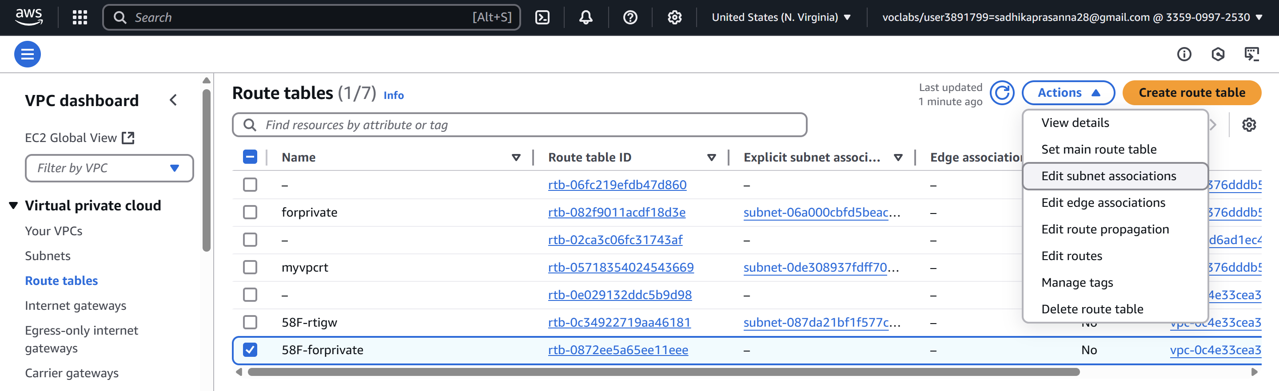

Select dbserver which is private subnet

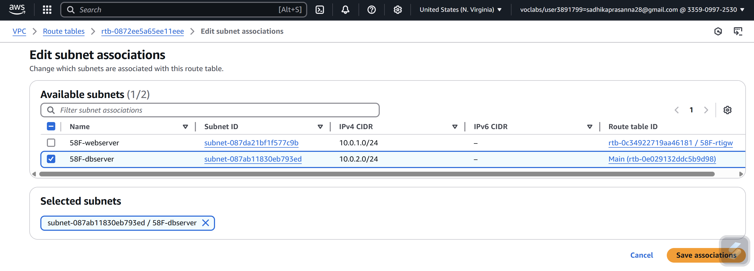

Now try connecting to dbserver from bastionserver putty -> It will get connected

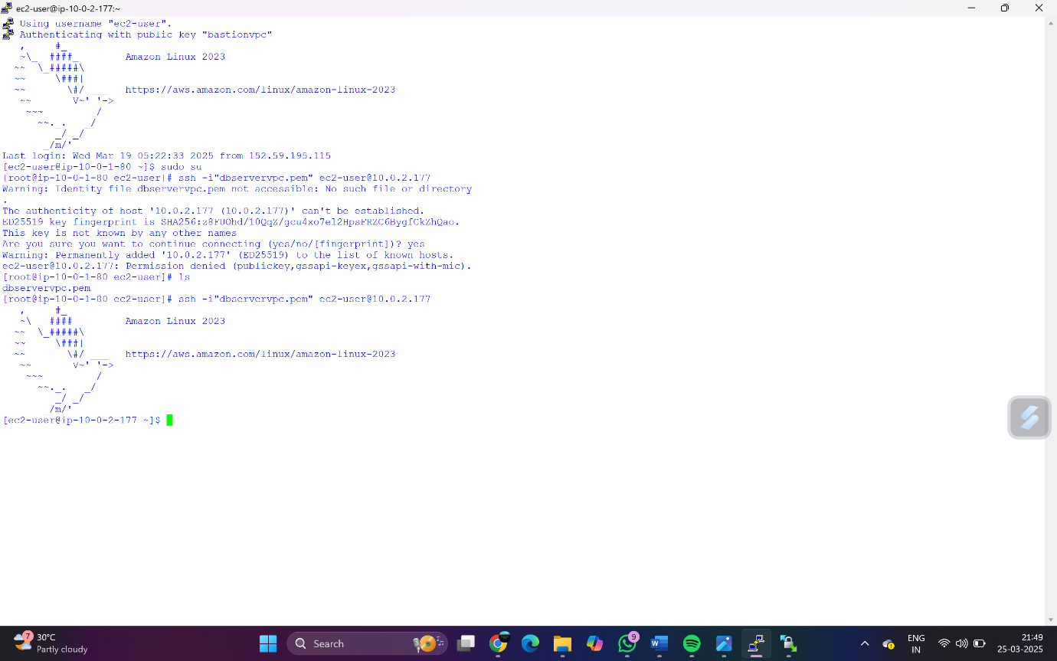

To verify whether connected to internet or not -> ping google.com -> Displays the IP

